<https://www.sciencedirect.com/science/article/abs/pii/S0969699720305147?via%3Dihub>

## [Journal of Air Transport Management](https://www.sciencedirect.com/science/journal/09696997)

[Volume 89](https://www.sciencedirect.com/science/journal/09696997/89/supp/C), October 2020, 101931

# Government support to airlines in the aftermath of the COVID-19 pandemic

На русском: <https://www.ncbi.nlm.nih.gov/pmc/articles/PMC7489892/>

# Государственная поддержка авиакомпаний после пандемии COVID-19

**Абстрактный**

В этом документе меры государственной поддержки сектора воздушного транспорта после вспышки пандемии коронавируса (COVID-19) оцениваются с двух точек зрения. Во-первых, исследуются факторы, определяющие готовность правительств поддерживать авиакомпании. Затем следует обсуждение различных типов поддержки, которая может быть предоставлена, и того, как параметры конкретной страны влияют на выбор мер. Во-вторых, в нем анализируются последствия государственной поддержки по трем направлениям, имеющим отношение к политике в области воздушного транспорта: конкуренция и либерализация, владение и контроль авиакомпаний, а также экологическая устойчивость. Анализ показывает, что большинство правительств уделяют первоочередное внимание поддержанию авиатранспортной связи в целях защиты экономической деятельности и рабочих мест как в самой авиации, так и в смежных секторах, таких как туризм. Компромисс между обеспечением связи и поддержанием конкуренции после пандемии COVID-19 - это проблема, имеющая несколько политических и экономических аспектов. Переориентация государственной политики после пандемии может ограничить относительную важность политических приоритетов, которые определяли эволюцию сектора воздушного транспорта до кризиса, особенно тех, которые связаны с изменением климата и окружающей средой. Роль правительства и государственных органов на всех уровнях - особенно тип и продолжительность мер, влияющих на транспортные операции, - будет иметь решающее значение для будущего развития авиационной отрасли.

**Ключевые слова:**воздушный транспорт, авиация, COVID-19, государственная политика, приватизация, либерализация, взаимодействие.

[J Air Transp Manag.](https://www.ncbi.nlm.nih.gov/pmc/articles/PMC7489892/) 2020 Oct; 89: 101931.

Published online 2020 Sep 14. doi: [10.1016/j.jairtraman.2020.101931](https://dx.doi.org/10.1016%2Fj.jairtraman.2020.101931)

PMCID: PMC7489892

PMID: [32952317](https://www.ncbi.nlm.nih.gov/pubmed/32952317)

# Government support to airlines in the aftermath of the COVID-19 pandemic[☆](https://www.ncbi.nlm.nih.gov/pmc/articles/PMC7489892/#d33e1288)

[Megersa Abate](https://www.ncbi.nlm.nih.gov/pubmed/?term=Abate%20M%5BAuthor%5D&cauthor=true&cauthor_uid=32952317),a,∗ [Panayotis Christidis](https://www.ncbi.nlm.nih.gov/pubmed/?term=Christidis%20P%5BAuthor%5D&cauthor=true&cauthor_uid=32952317),b and [Alloysius Joko Purwanto](https://www.ncbi.nlm.nih.gov/pubmed/?term=Purwanto%20AJ%5BAuthor%5D&cauthor=true&cauthor_uid=32952317)c

[Author information](https://www.ncbi.nlm.nih.gov/pmc/articles/PMC7489892/) [Article notes](https://www.ncbi.nlm.nih.gov/pmc/articles/PMC7489892/) [Copyright and License information](https://www.ncbi.nlm.nih.gov/pmc/articles/PMC7489892/) [Disclaimer](https://www.ncbi.nlm.nih.gov/pmc/about/disclaimer/)

This article has been [cited by](https://www.ncbi.nlm.nih.gov/pmc/articles/PMC7489892/citedby/) other articles in PMC.

## Associated Data

[Supplementary Materials](https://www.ncbi.nlm.nih.gov/pmc/articles/PMC7489892/)

[Go to:](https://www.ncbi.nlm.nih.gov/pmc/articles/PMC7489892/)

## Abstract

This paper assesses government support measures to the air transport sector following the outbreak of the coronavirus disease (COVID-19) pandemic from two points of view. First, it explores the factors that shape governments’ willingness to support airlines. This is followed by a discussion on the various types of support that may be provided and how country-specific parameters influence the choice of measures. Second, it analyses the implications of government support in three dimensions relevant to air transport policy: competition and liberalisation, airline ownership and control, and environmental sustainability. The analysis suggests that most governments give a high priority to maintaining air transport connectivity in order to protect economic activity and jobs, in aviation itself and in related sectors such as tourism. The trade-off between ensuring connectivity and maintaining competition after the COVID-19 pandemic is a challenge with several political and economic dimensions. The re-orientation of public policy in the aftermath of the pandemic may limit the relative importance of the policy priorities that shaped the evolution of the air transport sector before the crisis, especially those related to climate change and the environment. The role of government and public authorities at all levels – especially the type and duration of measures affecting transport operations – will be crucial for the future development of the aviation industry.

**Keywords:**Air transport, Aviation, COVID-19, Public policy, Privatisation, Liberalisation, Connectivity

[Go to:](https://www.ncbi.nlm.nih.gov/pmc/articles/PMC7489892/)

## 1. Introduction

During the first half of 2020, the coronavirus disease (COVID-19) pandemic had far-reaching implications for society. Apart from the obvious direct impact on health and mortality, the measures applied to control the spread of the disease caused major disruptions in economic activity that will probably be followed by a long recovery period. Aviation was particularly hit, with a 50% decrease in the total number of flights globally during April and May 2020. Several countries saw their air transport activity decrease by over 90% for 2 months or more ([European Commission, 2020a](https://www.ncbi.nlm.nih.gov/pmc/articles/PMC7489892/#bib24),[European Commission, 2020b](https://www.ncbi.nlm.nih.gov/pmc/articles/PMC7489892/#bib25)).

The high capital costs of airlines and airports make the survival of several actors questionable in the short term, as for instance, the typical airline has cash to cover only around two months of revenue loss ([IATA, 2020a](https://www.ncbi.nlm.nih.gov/pmc/articles/PMC7489892/#bib35)). The medium-term perspective of aviation is also bleak, since air travel is likely to be affected by a decrease in demand for tourism and for business travel at least until the end of 2021. To ameliorate these negative consequences, several countries are (or will be) supporting financially their national carriers and other participants in the aviation value chain. The support measures are mainly aimed at ensuring essential connectivity during the pandemic and protecting the millions of jobs the industry supports. They also constitute an indirect support to travel-sensitive sectors of the economy such as tourism to enable a faster rebound in the post COVID-19 recovery phase. Whilst these could be defensible reasons to support the industry from an individual country's perspective, the size and uneven distribution of confirmed and/or reported outlays raise issues of unfair competition and could distort the playing field of the international air transport market in the future.

This paper addresses government support measures to the air transport sector following the COVID-19 pandemic from two points of view. First, it explores the factors that shape governments’ willingness to support airlines. It then discusses the various types of support that may be provided and how country-specific parameters influence the choice of measures. Such parameters may include market size, market openness, connectivity, local economic and employment conditions, exposure to the pandemic, and the financial strengths of operators and countries. Second, the paper analyses the implications of government support in three dimensions relevant to air transport policy: competition and liberalisation, airline ownership and control, and environmental sustainability.

Even though the aviation sector is gradually becoming a more competitive and market-driven industry, the role of governments in promoting national interests through interventions in air transport at both national and international levels has not diminished. Aviation is seen by most governments as a strategic sector closely linked with economic development ([Zhang and Graham, 2020](https://www.ncbi.nlm.nih.gov/pmc/articles/PMC7489892/#bib72)), and as a result is directly or indirectly supported across several parts of its value chain. Aviation policies, like other economic policies, reflect a balance between the interests of consumers and the aviation and tourism industries ([Abate, 2016](https://www.ncbi.nlm.nih.gov/pmc/articles/PMC7489892/#bib1)). Support can be in the form of selective subsidies to operators, manufacturers, or service providers ([Gössling et al., 2017](https://www.ncbi.nlm.nih.gov/pmc/articles/PMC7489892/" \l "bib30)), or of interventions that restrict market access to potential competitors ([Christidis, 2016](https://www.ncbi.nlm.nih.gov/pmc/articles/PMC7489892/" \l "bib15)) and create monopolistic bottlenecks ([Knieps, 2014](https://www.ncbi.nlm.nih.gov/pmc/articles/PMC7489892/" \l "bib40)). National and regional air transport development policies are often centred around ensuring domestic and international aviation connectivity, since the number and frequency of aviation connections are strongly correlated with economic growth ([Njoya et al., 2018](https://www.ncbi.nlm.nih.gov/pmc/articles/PMC7489892/" \l "bib51)).

The issue of climate change is another area where the Governments' role in the industry has been increasing in recent years. So much so that COVID-19 prompted airline supports in France and Austria contain environmental conditionalities as discussed in Section [3.3](https://www.ncbi.nlm.nih.gov/pmc/articles/PMC7489892/#sec3.3) below. Even if the aviation sector's contribution to the global greenhouse gas emission is rather limited, the sector growth is strong ([Gösling et al. (2009)](https://www.ncbi.nlm.nih.gov/pmc/articles/PMC7489892/" \l "bib29);[Graver et al. (2019)](https://www.ncbi.nlm.nih.gov/pmc/articles/PMC7489892/#bib31)). Since 2012, CO2 emissions from aviation have been included in the EU emissions trading system (EU ETS). In 2016, an agreement was reached at the International Civil Aviation Organization (ICAO) to set up the Carbon Offsetting and Reduction Scheme for International Aviation (CORSIA) where as of July 2020, 88 States intend to volunteer to offset their emissions from 2021, representing more than 76% of the international aviation activity.

An expression of the importance of connectivity for reasons of national interest as opposed to free market conditions is the widely used public service obligation scheme, which subsidises airline connections to non-profitable destinations ([Merkert and Williams, 2013](https://www.ncbi.nlm.nih.gov/pmc/articles/PMC7489892/" \l "bib47)). The definitions and impacts of subsidies and other forms of support vary considerably depending on the context. The net result and the government reaction – which to a certain extent may be proportional to the magnitude of the net result – depend on the combination of the impacts on the various stakeholders, including airlines, employees, passengers, and wider economic benefits such as connectivity ([Forsyth and Guiomard, 2019](https://www.ncbi.nlm.nih.gov/pmc/articles/PMC7489892/#bib27)).

The other side of the coin of government interference in aviation, however, is the distortion of competition and the creation of additional hurdles that prevent a level playing field ([Tretheway and Andriulaitis, 2015](https://www.ncbi.nlm.nih.gov/pmc/articles/PMC7489892/" \l "bib64)). Increased policy intervention can reverse part of the progress made regarding the liberalisation of the air transport market and the resulting benefits for users and operators ([Abate and Christidis, 2020](https://www.ncbi.nlm.nih.gov/pmc/articles/PMC7489892/#bib2)). A bias in favour of national operators was already evident even in supposedly open aviation markets such as in the United States (US) ([Morrison and de Wit, 2019](https://www.ncbi.nlm.nih.gov/pmc/articles/PMC7489892/#bib49)) and additional government support will probably accentuate these imbalances.

The rest of the paper is structured as follows. Section [2](https://www.ncbi.nlm.nih.gov/pmc/articles/PMC7489892/#sec2) explores the determinants of government support to airlines through a comparison of the types of measures and several economic and operational indicators. Section [3](https://www.ncbi.nlm.nih.gov/pmc/articles/PMC7489892/#sec3) discusses the implications of government support to airlines in three main aspects: competition, privatisation, and sustainability. Finally, Section [4](https://www.ncbi.nlm.nih.gov/pmc/articles/PMC7489892/#sec4) summarises the discussion and draws the main conclusions.

[Go to:](https://www.ncbi.nlm.nih.gov/pmc/articles/PMC7489892/)

## 2. Exploratory assessment of determinants of government support

In order to explore the determinants of government support to airlines, two set of data were collected. The first set is a database of the various support measures that have been announced globally by combining several news sources and official government or airline press releases (Ishka ([Mariz, 2020a](https://www.ncbi.nlm.nih.gov/pmc/articles/PMC7489892/#bib44)), <https://www.transportenvironment.org/sites/te/files/Airline-bailout-tracker_8_May_2020.pdf>, [Transport and Environment (2020)](https://www.ncbi.nlm.nih.gov/pmc/articles/PMC7489892/#bib63), <https://www.eurocontrol.int/>, [EUROCONTROL (2020)](https://www.ncbi.nlm.nih.gov/pmc/articles/PMC7489892/#bib23), <https://home.treasury.gov/policy-issues/cares>, US CARES Act ([GovTrack.us., 2020](https://www.ncbi.nlm.nih.gov/pmc/articles/PMC7489892/#bib66))). For each support measure record, the database identifies the supporting entity, the recipients, the type and budget of the support measure, and the financial and employment figures of the recipients. A second dataset was constructed on the operational characteristics of the domestic and international air transport market in each country using data from SABRE™ Airlines Solutions for the year 2019. The main indicators include passenger traffic, revenue, number of connections, number of operating airlines, market concentration index, and share of the largest airline for the domestic and international markets of each country.

Section [2.1](https://www.ncbi.nlm.nih.gov/pmc/articles/PMC7489892/#sec2.1) discusses the various types of support and how they are correlated with the importance of the aviation sector in each country and develop an explanatory model. Section [2.2](https://www.ncbi.nlm.nih.gov/pmc/articles/PMC7489892/#sec2.2) elaborates on the aspects of connectivity and competition and explore how they can be affected by the foreseen unbalanced provision of government support.

### 2.1. Economic and financial factors

[Fig. 1](https://www.ncbi.nlm.nih.gov/pmc/articles/PMC7489892/figure/fig1/) and [Fig. 2](https://www.ncbi.nlm.nih.gov/pmc/articles/PMC7489892/figure/fig2/) display hitherto proposed or confirmed monetarily quantified relief measures for airlines provided by governments or government-backed entities across 57 countries. As of August 20, 2020, these measures tally close to US$159 billion, which is 38% of the total projected revenue loss for airlines of US$419 billion in 2020 ([IATA, 2020a](https://www.ncbi.nlm.nih.gov/pmc/articles/PMC7489892/#bib35)). For border context, the amount of COVID-19 prompted rescue and recovery spending in G20 countries is reported to be US$ 7.3 trillion (Hepburn et al.,2020).

[[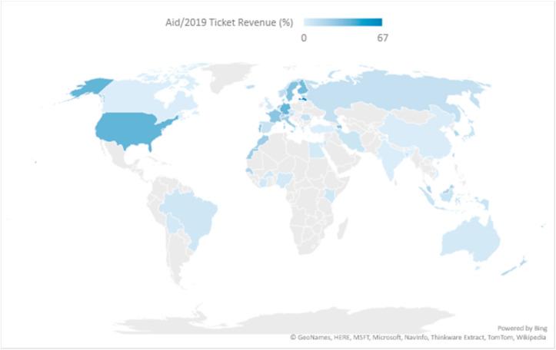](https://www.ncbi.nlm.nih.gov/core/lw/2.0/html/tileshop_pmc/tileshop_pmc_inline.html?title=Click%20on%20image%20to%20zoom&p=PMC3&id=7489892_gr1_lrg.jpg)](https://www.ncbi.nlm.nih.gov/core/lw/2.0/html/tileshop_pmc/tileshop_pmc_inline.html?title=Click%20on%20image%20to%20zoom&p=PMC3&id=7489892_gr1_lrg.jpg" \t "tileshopwindow)

[Open in a separate window](https://www.ncbi.nlm.nih.gov/pmc/articles/PMC7489892/figure/fig1/?report=objectonly)

[Fig. 1](https://www.ncbi.nlm.nih.gov/pmc/articles/PMC7489892/figure/fig1/)

Geographic distribution of Government financial aid normalised by 2019 ticket revenue.

Source: Authors' calculations using SABRE and Ishka Global Data.

[[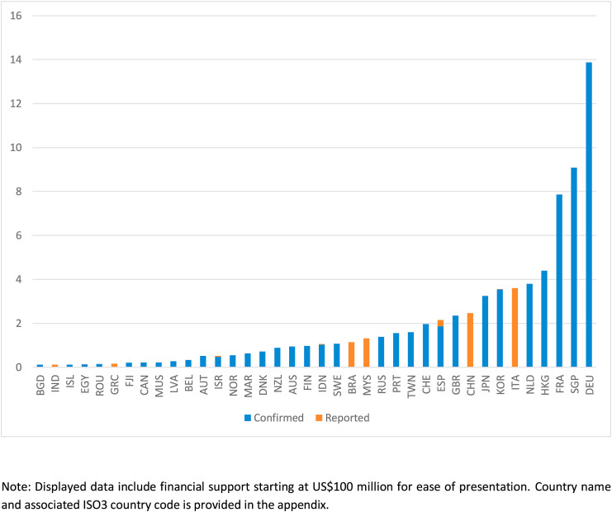](https://www.ncbi.nlm.nih.gov/core/lw/2.0/html/tileshop_pmc/tileshop_pmc_inline.html?title=Click%20on%20image%20to%20zoom&p=PMC3&id=7489892_gr2_lrg.jpg)](https://www.ncbi.nlm.nih.gov/core/lw/2.0/html/tileshop_pmc/tileshop_pmc_inline.html?title=Click%20on%20image%20to%20zoom&p=PMC3&id=7489892_gr2_lrg.jpg" \t "tileshopwindow)

[Open in a separate window](https://www.ncbi.nlm.nih.gov/pmc/articles/PMC7489892/figure/fig2/?report=objectonly)

[Fig. 2](https://www.ncbi.nlm.nih.gov/pmc/articles/PMC7489892/figure/fig2/)

US$159 billion in confirmed or proposed government support.

Note: Displayed data include financial support starting at US$100 million for ease of presentation. Country name and associated ISO3 country code is provided in the appendix.

Source: Ishka Global, IATA.

Several countries have availed of government support to their aviation sector, which falls into seven broad archetypes: government-backed commercial loans and government guarantees; recapitalisation through state equity; flight subsidies, nationalisation; deferral and/or waiver of taxes and charges; grants; and private equity ([Fig. 3](https://www.ncbi.nlm.nih.gov/pmc/articles/PMC7489892/figure/fig3/) ).

[[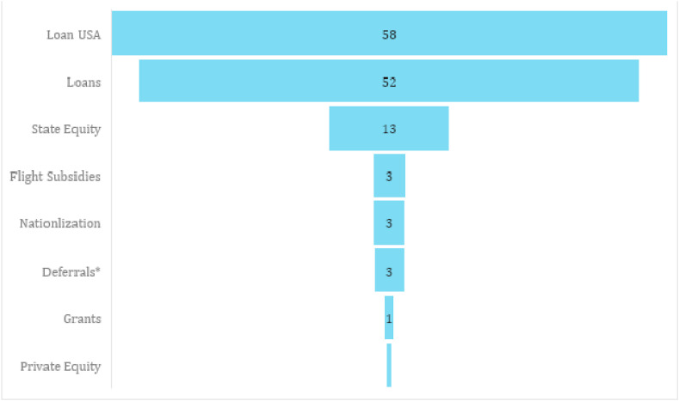](https://www.ncbi.nlm.nih.gov/core/lw/2.0/html/tileshop_pmc/tileshop_pmc_inline.html?title=Click%20on%20image%20to%20zoom&p=PMC3&id=7489892_gr3_lrg.jpg)](https://www.ncbi.nlm.nih.gov/core/lw/2.0/html/tileshop_pmc/tileshop_pmc_inline.html?title=Click%20on%20image%20to%20zoom&p=PMC3&id=7489892_gr3_lrg.jpg" \t "tileshopwindow)

[Open in a separate window](https://www.ncbi.nlm.nih.gov/pmc/articles/PMC7489892/figure/fig3/?report=objectonly)

[Fig. 3](https://www.ncbi.nlm.nih.gov/pmc/articles/PMC7489892/figure/fig3/)

Government-backed Commercial Loans and Guarantees are Main Forms of Support (US$ billion).

Notes: \*Includes US$1.19 billion fees/charges deferral from EUROCONTROL, a European air navigation service provider for European Union-based airlines. Loan USA refers to a US$58 billion bailout for US airlines (US$61 billion including grants for contractors), which was signed into law on March 27, 2020 as part of the CARES Act. The USA is considering further US$25 billion support for its aviation industry after the current CARES Act expires in September 2020.

Source: Authors' compilation based on data from [Ishka](https://www.ishkaglobal.com/News/Article/6264/Covid-19-bailouts-Seven-carriers-get-2-8bn-in-new-and-additional-aid" \t "_blank), [Transport and Environment](https://www.transportenvironment.org/sites/te/files/Airline-bailout-tracker_8_May_2020.pdf), [EUROCONTROL](https://www.eurocontrol.int/), [US CARES Act](https://home.treasury.gov/policy-issues/cares).

Arguably, of the seven government support measures, nationalisation and recapitalisation (swapping debt for equity) will most likely increase the direct role of the government in the aviation industry for the foreseeable future. Whilst the other types of support will also increase the role of the government in the industry for a few years, especially if there are stringent preconditions to get a loan or a loan guarantee, the governments' direct role will wane once airlines pay back loans. Nationalisation or recapitalisation measures, on the other hand, may result in a more prolonged government presence in the airlines’ corporate structure.

To understand the pattern of governments’ financial aid, we used a two-part or hurdle regression model that estimates the probability of government support (using a Probit model) and the correlates of government aid size conditional on support (using a linear model).[1](https://www.ncbi.nlm.nih.gov/pmc/articles/PMC7489892/#fn1) The Probit model is based on a sample of 102 countries which has a mix of countries with reported/confirmed government aid and those without known support for their airlines. Whereas the linear model uses a sample of 57 countries with known and quantified government aid to airlines. The main explanatory variables used in the analysis include, the estimated revenue loss from March to May 2020, the extent to which a country relies on international travel, the number of domestic airlines and their employees, income, airline ownership structure and macroeconomic condition of a country.[2](https://www.ncbi.nlm.nih.gov/pmc/articles/PMC7489892/#fn2)

[Table 1](https://www.ncbi.nlm.nih.gov/pmc/articles/PMC7489892/table/tbl1/) shows that most of the explanatory variables are statistically significant and give plausible coefficient estimates. Richer countries and those with larger number of domestic airlines are shown to have both a higher tendency to support airlines and provide larger sum. Estimated revenue loss in recent months is also positively correlated with government aid. While government majority ownership in airlines does not appear to affect the probability or size of support consistently, it has small but significant effect in the 50–75% ownership range. This is perhaps because the US and Germany, where there is no direct government ownership of airlines, have provided about 53% of the total confirmed support so far. In contrast, the average government ownership of an airline for the whole sample is about 47%.

### Table 1

Correlates of government financial support to airlines.

| **Dependent Variable** | **Probability of Government Support** | **Log. Financial Aid** | **Log. Financial Aid** |
| --- | --- | --- | --- |
| Log Airline Employment Size |  | 0.454\*\*\* | 0.461\*\*\* |
|  |  | (0.123) | (0.124) |
| Log Airline Ticket Revenue Loss |  | 0.158\*\* | 0.165\*\* |
|  |  | (0.0744) | (0.0732) |
| Log Per Capita GDP | 0.265\*\* | 0.379\*\*\* | 0.324\*\* |
|  | (0.112) | (0.134) | (0.144) |
| International Revenue Dependence |  | 1.485\*\* | 1.720\*\*\* |
|  |  | (0.563) | (0.552) |
| Current Account Balance |  | 0.0607\*\* | 0.0597\*\* |
|  |  | (0.0268) | (0.0263) |
| Number of Domestic Airlines | 0.135\*\* | 0.0332\*\* | 0.0371\*\*\* |
|  | (0.0549) | (0.0124) | (0.0120) |
| Majority State Airline Ownership | 0.453 | 0.241 |  |
|  | (0.335) | (0.315) |  |
| 1–25% Government Ownership |  |  | 0.451 |
|  |  |  | (0.560) |
| 25–49% Government Ownership |  |  | 0.00879 |
|  |  |  | (0.486) |
| 50–75% Government Ownership |  |  | 0.851\*\* |
|  |  |  | (0.393) |
| >75% Government Ownership |  |  | 0.168 |
|  |  |  | (0.443) |
| Constant | −2.447\*\* | −13.24\*\*\* | −13.29\*\*\* |
|  | (1.088) | (1.521) | (1.630) |
| Number of Observations | 102 | 57 | 57 |
| Pseudo R2 | 0.19 |  |  |
| R-squared |  | 0.81 | 0.83 |

[Open in a separate window](https://www.ncbi.nlm.nih.gov/pmc/articles/PMC7489892/table/tbl1/?report=objectonly)

Notes: Standard errors in parentheses \*\*\*p < 0.01, \*\*p < 0.05, \*p < 0.1. GDP = gross domestic product, Pax = passenger.

Source: Authors based on data from World Development Indicators, airline websites, Ishka Global.

The positive effect of a country's macroeconomic situation on aid size is evident both in [Table 1](https://www.ncbi.nlm.nih.gov/pmc/articles/PMC7489892/table/tbl1/) and [Fig. 4](https://www.ncbi.nlm.nih.gov/pmc/articles/PMC7489892/figure/fig4/) , which depicts the relationship between aid and the balance of payment situation of a country. The extent to which countries depend on international markets for passenger demand and revenue is also shown to affect government aid positively. What follows provides detailed look at this relationship.

[[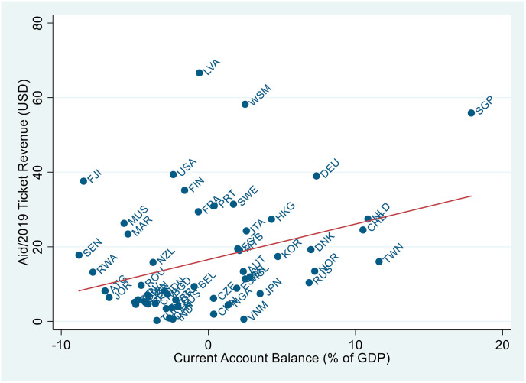](https://www.ncbi.nlm.nih.gov/core/lw/2.0/html/tileshop_pmc/tileshop_pmc_inline.html?title=Click%20on%20image%20to%20zoom&p=PMC3&id=7489892_gr4_lrg.jpg)](https://www.ncbi.nlm.nih.gov/core/lw/2.0/html/tileshop_pmc/tileshop_pmc_inline.html?title=Click%20on%20image%20to%20zoom&p=PMC3&id=7489892_gr4_lrg.jpg" \t "tileshopwindow)

[Open in a separate window](https://www.ncbi.nlm.nih.gov/pmc/articles/PMC7489892/figure/fig4/?report=objectonly)

[Fig. 4](https://www.ncbi.nlm.nih.gov/pmc/articles/PMC7489892/figure/fig4/)

Financial Support vs. Current Account Balance

GDP =

gross domestic product.

Sources: Authors based on data from World Development Indicators and Ishka Global.

[Fig. 5](https://www.ncbi.nlm.nih.gov/pmc/articles/PMC7489892/figure/fig5/) divides our sample into three interesting groups based on the gap between their international versus domestic passenger numbers and ticket revenue in 2019. A higher (positive) value for both axes show higher dependence on international (foreign) markets for revenue and passenger traffic. Countries in the top right corner of the quadrant, i.e. those which rely on international passengers for revenue and traffic, tend to provide more aid (bigger bubble size). This is in part due to the role of airlines as a strategic productive industry in these countries (e.g. Singapore, Hong Kong, the Netherlands, Rwanda)[3](https://www.ncbi.nlm.nih.gov/pmc/articles/PMC7489892/#fn3) and the lack of domestic air transport market as a fall back. Countries in the lower left corner generate most of their passengers and revenue in the domestic market. Except for the US (not shown the Figure), these countries do not appear to provide much aid. The third category are those countries in upper-left quadrant where the passenger market is dominated by domestic travellers, whilst most of the revenue comes from the international segment. Countries in this category, to some degree those with balanced distribution of the international and domestic market (e.g. the Russian Federation and Japan), do not give much aid either. Their large domestic markets, however, will prove to be crucial for an early recovery before international borders are fully opened.

[[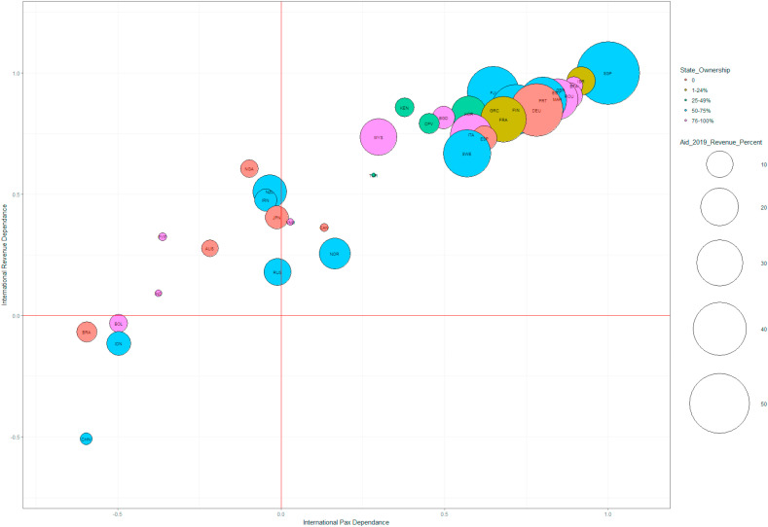](https://www.ncbi.nlm.nih.gov/core/lw/2.0/html/tileshop_pmc/tileshop_pmc_inline.html?title=Click%20on%20image%20to%20zoom&p=PMC3&id=7489892_gr5_lrg.jpg)](https://www.ncbi.nlm.nih.gov/core/lw/2.0/html/tileshop_pmc/tileshop_pmc_inline.html?title=Click%20on%20image%20to%20zoom&p=PMC3&id=7489892_gr5_lrg.jpg" \t "tileshopwindow)

[Open in a separate window](https://www.ncbi.nlm.nih.gov/pmc/articles/PMC7489892/figure/fig5/?report=objectonly)

[Fig. 5](https://www.ncbi.nlm.nih.gov/pmc/articles/PMC7489892/figure/fig5/)

Financial Support and Domestic–International Passenger Demand/Revenue GapBubble

size =

Aid Per Ticket Revenue of 2019 (%).

Source: Authors, based on data from World Development Indicators, airline websites, Ishka Global.

[Fig. 6](https://www.ncbi.nlm.nih.gov/pmc/articles/PMC7489892/figure/fig6/) provides a similar analysis using a bigger sample for countries with connections with more than 12,000 passengers annually. Those in quadrant one are countries that generate most of their air transport demand and revenue internationally. Most of European and African countries feature prominently in this quadrant. While this is likely due to geography in Europe, under development of air transport infrastructure and low income explain sparse domestic demand in Africa. As for individual countries, the Netherlands (in Europe) and the UAE (in Asia) top this quadrant. Those in quadrant three (lower left quadrant) are the reverse, topped by China and the US, those with big domestic markets. Interestingly, countries in quadrant two (upper left quadrant) carry fewer international passengers but generate more revenue from the segment than from domestic travel. Thanks to bigger domestic markets, quadrant three countries will likely recover rapidly. Quadrant two countries will probably also recover quickly, especially if they could charge higher domestic fares to compensate for loss in international revenue. With the current international border closures, the most vulnerable countries are those in quadrant one.

[[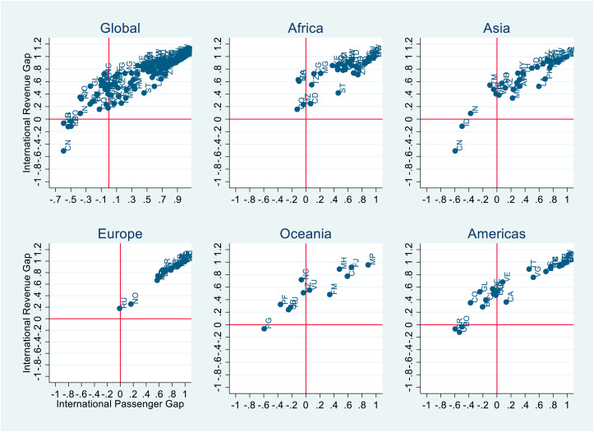](https://www.ncbi.nlm.nih.gov/core/lw/2.0/html/tileshop_pmc/tileshop_pmc_inline.html?title=Click%20on%20image%20to%20zoom&p=PMC3&id=7489892_gr6_lrg.jpg)](https://www.ncbi.nlm.nih.gov/core/lw/2.0/html/tileshop_pmc/tileshop_pmc_inline.html?title=Click%20on%20image%20to%20zoom&p=PMC3&id=7489892_gr6_lrg.jpg" \t "tileshopwindow)

[Open in a separate window](https://www.ncbi.nlm.nih.gov/pmc/articles/PMC7489892/figure/fig6/?report=objectonly)

[Fig. 6](https://www.ncbi.nlm.nih.gov/pmc/articles/PMC7489892/figure/fig6/)

Domestic vs. International Passenger and Revenue Reliance.

Source: Authors' calculations using SABRE data; connections with more than 12,000 passengers annually.

### 2.2. Connectivity and competition

A measure of the relative importance of the air transport sector in each country's economy can be the connectivity at domestic and international levels. The population size and geography, the economic profile of each country, and the role they play in the international aviation market influence the balance in the national priorities as regards the two types of market. There are various ways to measure airport connectivity, in most cases an expression of the number of distinct direct connections served by an airport that meet certain frequency or traffic conditions is used. The two largest markets for aviation in passengers and revenue, the US and China (CHN), have a significantly higher number of domestic than international connections (applying a threshold of 12 thousand passengers annually). This can be explained by the size of the countries, the distribution of their economic activities, and the mature development of the air transport networks ([Fig. 7](https://www.ncbi.nlm.nih.gov/pmc/articles/PMC7489892/figure/fig7/) ). The United Kingdom (GBR), Germany (DEU), and France (FRA) show a different pattern, with a large number of international connections and a limited number of domestic ones. Obviously, their smaller size compared to the US and China explains the lower number of domestic connections, whilst their close economic ties with other European countries are the reason for the large number of international connections (though if European Union as a whole is considered as a single entity, the definition of domestic flights would change).

[[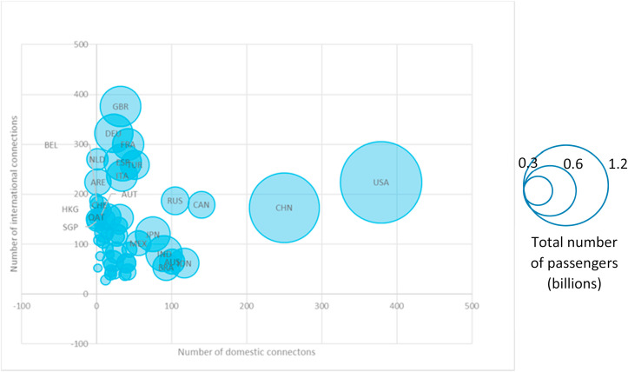](https://www.ncbi.nlm.nih.gov/core/lw/2.0/html/tileshop_pmc/tileshop_pmc_inline.html?title=Click%20on%20image%20to%20zoom&p=PMC3&id=7489892_gr7_lrg.jpg)](https://www.ncbi.nlm.nih.gov/core/lw/2.0/html/tileshop_pmc/tileshop_pmc_inline.html?title=Click%20on%20image%20to%20zoom&p=PMC3&id=7489892_gr7_lrg.jpg" \t "tileshopwindow)

[Open in a separate window](https://www.ncbi.nlm.nih.gov/pmc/articles/PMC7489892/figure/fig7/?report=objectonly)

[Fig. 7](https://www.ncbi.nlm.nih.gov/pmc/articles/PMC7489892/figure/fig7/)

Domestic and International Connectivity (number of distinct connections), 2019

Source: Authors' calculations using SABRE data; connections with more than 12,000 passengers annually.

A second relevant indicator when comparing the domestic and the international market for each country is market concentration using the well-known Herfindahl–Hirschman Index (HHI):

HHI = Σi si2

where i is each airline competing in a country's domestic or international market, and si is the market share in terms of revenue of airline i in this market. Higher values correspond to higher market concentration. A value of 1 would mean that a single operator occupies the whole market.

[Fig. 8](https://www.ncbi.nlm.nih.gov/pmc/articles/PMC7489892/figure/fig8/) summarises the domestic and international market concentration in terms of revenue for each country, with the bubble size corresponding to the total revenue of airlines in the country. China and the US appear to be amongst the most competitive markets in this sense, with low HHI for both domestic and international markets. In China, the five biggest competitors generate a relatively modest 64% of the total domestic revenue and only 40% of the total international revenue. In the US, the four biggest airlines (Delta, American, United, Southwest) concentrate 84% of the domestic revenue, each with a comparable share of between 15% and 24%. The four airlines control 42% of the international market of the US.

[[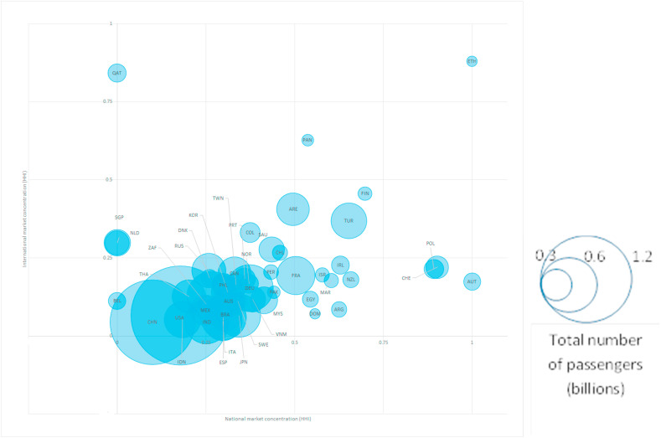](https://www.ncbi.nlm.nih.gov/core/lw/2.0/html/tileshop_pmc/tileshop_pmc_inline.html?title=Click%20on%20image%20to%20zoom&p=PMC3&id=7489892_gr8_lrg.jpg)](https://www.ncbi.nlm.nih.gov/core/lw/2.0/html/tileshop_pmc/tileshop_pmc_inline.html?title=Click%20on%20image%20to%20zoom&p=PMC3&id=7489892_gr8_lrg.jpg" \t "tileshopwindow)

[Open in a separate window](https://www.ncbi.nlm.nih.gov/pmc/articles/PMC7489892/figure/fig8/?report=objectonly)

[Fig. 8](https://www.ncbi.nlm.nih.gov/pmc/articles/PMC7489892/figure/fig8/)

Market Concentration in Domestic and International Markets (HHI of revenue), 2019

HHI =

Herfindahl–Hirschman Index.

Source: Authors' calculations using SABRE data

Singapore (SGP) does not have a domestic air transport market but has invested significantly in its role as a hub for international travel. The sector represents 5% of Singapore's GDP and generates more than 19,000 jobs. Whilst a significant number of airlines operate out of its airport (78, in the top 10% at country level globally), its flag carrier, Singapore Airlines (majority owned by the Singapore government) has a market share of 36% in terms of passengers and 53% in terms of revenue. In contrast, Belgium (BEL) – another country without a domestic market – does not have a flag carrier, even though Brussels is an important airport for connectivity with Europe, Africa, and the rest of the world. As a result, the market share of the largest airline operating out of Belgium (Brussels Airlines) is 27% and 28% in terms of passengers and revenue, respectively. Qatar (QAT) and Ethiopia (ETH) both have a highly concentrated international market, to a large extent controlled by their respective flag carriers. In the case of Ethiopia, the dominance of the flag carrier is also evident in its domestic market. Austria (AUT), Poland (POL), and Switzerland (CHE) have a dominant carrier in the domestic market, but a rather competitive international market.

As discussed in section [2.1](https://www.ncbi.nlm.nih.gov/pmc/articles/PMC7489892/#sec2.1), several of the governments in the largest aviation markets in the US, Europe, and Asia have declared their willingness to support their national carriers with various measures. There is still high uncertainty concerning the future, but it should be safe to assume that the flagship carriers and large operators in those countries will survive the post-pandemic crisis and recover a large part of their activity. Nevertheless, smaller operators and less-profitable routes may be at risk. The situation could be grim for large, mainly low-cost carriers, operating in the international market and not receiving any or only limited support from national governments.

Whilst lower demand also affects hub airports and bigger airlines, some smaller point-to-point direct routes may disappear completely under this situation, and instead shift to hubs resulting in the consolidation of bigger hubs and airlines. At the same time, some smaller hubs would lose the critical mass to allow efficient transit operations and would be limited to serving mainly point-to-point connections. This consolidation and dispersion process can affect both intra-regional and long-distance (intercontinental) air passenger trips. Intercontinental traffic is more vulnerable than intra-regional trips in terms of passenger demand, financial loss, and recovery time. During the pandemic and the initial recovery period the drop in intercontinental demand is mainly due to travel restrictions, but in the longer term, this demand is likely to remain low due mostly to the slowdown in economic activity.

Given the connectivity priorities and competition landscape across the world, three main mechanisms can be expected to influence air transport networks as a result of the post-pandemic government support measures:

* • Maintaining connectivity will depend to a large extent on the support given to domestic airlines. Countries that cannot afford to provide such support, especially in South America and Africa, may lose a part of the air transport connections.
* • The market share of the main national airlines will probably become even higher, since smaller players may exit the market. In addition, the network and scale economies will continue to play in favour of large network operators in both domestic and international markets.
* • A regression to a trend towards a hub-and-scope network model can be expected. Such a development may have negative repercussions on the average trip length and the resulting environmental footprint of the air transport sector.

[Go to:](https://www.ncbi.nlm.nih.gov/pmc/articles/PMC7489892/)

## 3. Implications of government financial support

The growing presence of governments in the sector has implications on at least three important areas. First, the growing government ownership has resurrected the perineal debate on government versus private ownership of airlines and its implication on efficiency and competition. Second, there is a growing concern that countries might retreat from the liberalisation and deregulation policies of the last 3 decades risking important progress made towards levelling the playing field. Third, befitting this decade's most pressing agenda, it is important to ask whether growing government involvement will slow or accelerate the environmental sustainability of the sector. What follows recaps the literature and recent developments on these three areas to draw key policy lessons.

### 3.1. Implications on liberalisation and/or deregulation

To understand the implications of COVID-19 crisis prompted government support on air transport market liberalisation, it is important to recap the recent focus on the issue from two contrasting perspectives as noted in [Abate and Christidis (2020)](https://www.ncbi.nlm.nih.gov/pmc/articles/PMC7489892/#bib2). On the one hand, the focus is mainly academic and geared towards assessment of major bilateral and multilateralliberalisation initiatives in the US ([Winston and Yan, 2015](https://www.ncbi.nlm.nih.gov/pmc/articles/PMC7489892/#bib70)), the EU ([Burghouwt and de Wit, 2015](https://www.ncbi.nlm.nih.gov/pmc/articles/PMC7489892/" \l "bib73)), Africa ([Abate, 2016](https://www.ncbi.nlm.nih.gov/pmc/articles/PMC7489892/#bib1); [InterVISTAS, 2014](https://www.ncbi.nlm.nih.gov/pmc/articles/PMC7489892/" \l "bib38)), Northeast Asia ([Adler et al., 2014](https://www.ncbi.nlm.nih.gov/pmc/articles/PMC7489892/#bib3)), and the Middle East ([Cristea et al., 2015](https://www.ncbi.nlm.nih.gov/pmc/articles/PMC7489892/" \l "bib18)). In all these studies, liberalisation policies have been shown to bring positive economic outcomes.

On the other hand, the renewed interest on liberalisation comes from the fear of ‘destructive competition’ ([Borenstein and Rose, 2007](https://www.ncbi.nlm.nih.gov/pmc/articles/PMC7489892/" \l "bib9)) or ‘heightened competition’ ([ICAO, 2013](https://www.ncbi.nlm.nih.gov/pmc/articles/PMC7489892/#bib75)) as more markets open-up. This fear is fuelled by the rapid expansion of the Gulf State airlines ([Dresner et al., 2015](https://www.ncbi.nlm.nih.gov/pmc/articles/PMC7489892/" \l "bib20)), the emergence of long-haul inter-continental flights by low-cost carriers ([De Poret, 2015](https://www.ncbi.nlm.nih.gov/pmc/articles/PMC7489892/#bib19)), and the dominance of global airline alliances ([OECD, 2014](https://www.ncbi.nlm.nih.gov/pmc/articles/PMC7489892/#bib54)). Similarly, [Goetz and Vowles (2009)](https://www.ncbi.nlm.nih.gov/pmc/articles/PMC7489892/#bib28) point to the negative consequences of the United States' domestic market opening such as poor airlines financial performance resulting in a series of bankruptcies which required public bailouts of workers' pension systems. These developments have resulted in policy uncertainty in major aviation markets such as the EU and the US, to the extent of endangering liberalisation efforts. Whilst the overall policy strategies are still aimed at building open aviation partnerships in many parts of the world, recent emphasis on issues like ‘fair competition’ and ‘level playing field’ has been interpreted by some as protectionist ([Morrison and de Wit, 2019](https://www.ncbi.nlm.nih.gov/pmc/articles/PMC7489892/#bib49)).

Contrary to ‘destructive competition’ arguments, the literature consistently shows that the fortunes of the air transport industry are largely determined by its cost structure, demand and fuel price fluctuations, and infrastructure bottlenecks ([Abate and Christidis, 2020](https://www.ncbi.nlm.nih.gov/pmc/articles/PMC7489892/#bib2)). For example, Europe’s major carriers are usually shown to have a higher cost base (especially labour) compared to their rivals. Some argue that this high cost base, not liberalisation, is making Europe lag other regions in terms of connectivity and airline profitability, to the extent of being bypassed as a global hub ([CAPA, 2014](https://www.ncbi.nlm.nih.gov/pmc/articles/PMC7489892/#bib11),[2016](https://www.ncbi.nlm.nih.gov/pmc/articles/PMC7489892/#bib12)). Thanks to deregulation, the expansion of low-cost carriers has stimulated cost cutting throughout the whole aviation industry, which has led to significant reductions in fares ([Brueckner et al., 2013](https://www.ncbi.nlm.nih.gov/pmc/articles/PMC7489892/" \l "bib10)). It is worth noting that lower fares are not entirely due to competition. For example, some European countries have given out aid to airports that reduced fares to some extent ([Malina et al., 2012](https://www.ncbi.nlm.nih.gov/pmc/articles/PMC7489892/" \l "bib43);[Ramos-Pérez, 2016](https://www.ncbi.nlm.nih.gov/pmc/articles/PMC7489892/#bib59)). Furthermore, the merits of competition should weigh wider consequences such as the impacts of low-cost base on workers' social welfare ([Harvey and Turnbull, 2010](https://www.ncbi.nlm.nih.gov/pmc/articles/PMC7489892/#bib32)) as well as the negative effect of increased traffic on the environment ([Flightnook Team, 2017](https://www.ncbi.nlm.nih.gov/pmc/articles/PMC7489892/" \l "bib26)).

Most of the confirmed or proposed financial support from governments has been targeted at saving the airlines and the millions of jobs they support. As governments are called on as the last resort, however, vigilance is needed not to distort the post COVID-19 playing field tilting the balance towards the underlying forces that are trying to deter further market openness or reverse it.

### 3.2. Implications for airline ownership

The COVID-19 crisis prompted government bailouts and/or financial support have made the topic of airline ownership structure as relevant as ever at least from two important dimensions. First, to help cash-strapped airlines during the crisis there is a call to liberalise ownership and control clauses in air services agreements that put a ceiling on foreign ownership ([Charlton, 2020](https://www.ncbi.nlm.nih.gov/pmc/articles/PMC7489892/#bib14);[Poole, 2020](https://www.ncbi.nlm.nih.gov/pmc/articles/PMC7489892/#bib58)). Second, there is a growing concern that the expansion of government capital in the sector may crowd out private capital to the extent of endangering or even reversing the privatisation process the industry has seen in recent decades ([Helm, 2020](https://www.ncbi.nlm.nih.gov/pmc/articles/PMC7489892/#bib33)). What follows explores both dimensions based on the evidence base in the literature.

International air transport activities are governed by rules that limit foreign ownership and control of airlines by prohibiting cross-border mergers and acquisitions. Most countries, including the European Union, have a maximum ownership limit of 49% for a foreign national entity to issue an air operators' certificate. The United States, whilst it pursues a liberal open skies policy on so called ‘hard rights’ such as fifth freedom rights, frequency and/or capacity provision, and airline designation, it permits a maximum of 25% foreign ownership for airlines to be incorporated in its territory. Given that much of the international air transport system is operated based on the principles of reciprocity under bilateral air services agreements, it has proven difficult for countries to unilaterally pursue a liberal policy on foreign ownership. This has left the industry to its own devices and resulted in innovative ownership and partnership models.

Airlines have used various strategies to circumvent these rules, including the creation of global alliances and the acquisition of minority stakes in other airlines. These can later serve as a prerequisite to a commercial partnership for an airline to build global connectivity and to gain market access ([O'Connell and Bueno, 2018](https://www.ncbi.nlm.nih.gov/pmc/articles/PMC7489892/#bib53)). Hub-and-spoke networks and equity investing have been extensively used by major carriers in the EU and the US to expand air transport services to thin markets and to evade the regulatory restrictions on ownership and control of airlines. Several airlines (e.g. Delta, Etihad, Ethiopian Airlines, and the future possible partnership between Singapore and Malaysia Airlines [[Leo, 2019](https://www.ncbi.nlm.nih.gov/pmc/articles/PMC7489892/#bib42)]) have used equity partnerships to tap into the fast-growing foreign markets. For their part, partnering countries and airlines gained from the boost in connectivity — a feat they could not have achieved due to their smaller market size or lack of operational and financial capabilities to run an airline.

For smaller countries and for countries with under-developed capital markets, international requirements that airlines providing international services should be ‘owned and controlled’ by nationals of that country can cause difficulties ([Andrew and Juan, 2005](https://www.ncbi.nlm.nih.gov/pmc/articles/PMC7489892/#bib5)). In these countries, the alternative approach to full privatisation or foreign ownership has been to seek a strategic investor to buy a partial stake in the airline, which usually needs active support and restructuring. A good example is that of Etihad Airways, which in recent years has bought minority stakes in several smaller airlines, including Air, Berlin, Air Serbia, Air Seychelles, Alitalia, India's Jet Airways, Virgin Australia, and the Swiss-based Darwin Airline ([Wober, 2017](https://www.ncbi.nlm.nih.gov/pmc/articles/PMC7489892/" \l "bib71)). Whilst some of Etihad's ventures have been successful, e.g. Air Serbia, there have been a number of high-profile failures, including the recent insolvency of Air Berlin and Alitalia.

Whilst strategic partnerships have their limits when an airline has fundamental problems that are difficult to solve regardless of the size of capital injection, they have offered a workable workaround for the industry to move capital and talent globally. The continuation of this model crucially depends on the presence of a favourable regulatory landscape that must be there in the post COVID-19 world.

The last 3 decades have seen increased flows of private capital into the air transport industry, but governments continue to play an important role, either in the form of direct ownership of national carriers or through the allocation of traffic rights and airline designation in air services agreements. The regulation of essential services under public service obligations and the provision of critical infrastructure (airports) and services (air navigation) continue to be under the purview of the government in many parts of the world. Given the pervasive nature of governments’ role in the industry, the main issue has not been about choosing between privatisation or government control. Rather, policymakers, for the most part, have always aimed at striking a good regulatory balance that attracts private capital and addresses the connectivity needs of citizens and countries.

Where there are competitive market conditions and/or good regulation, there is well-documented evidence that the policy of allowing private capital into the airline industry has improved the efficiency of the sector in many parts of the world ([Backx et al., 2002](https://www.ncbi.nlm.nih.gov/pmc/articles/PMC7489892/" \l "bib7);[Al-Jazzaf, 1999](https://www.ncbi.nlm.nih.gov/pmc/articles/PMC7489892/#bib4)). An earlier study on European airlines by [Ng and Seabright (2001)](https://www.ncbi.nlm.nih.gov/pmc/articles/PMC7489892/#bib50) showed that the percentage of government ownership in the industry is positively associated with higher costs, mainly because of weak corporate governance. They also found that government-owned European airlines had market power that led to lower labour and capital productivity, which in turn led to significantly higher operating costs compared to privately-owned United States’ airlines.

Since the mid-90s, almost every major Western European national airline has been privatised, although governments still retain stakes in many national airlines around the world ([Fig. 9](https://www.ncbi.nlm.nih.gov/pmc/articles/PMC7489892/figure/fig9/) ). Two extreme cases are North America, where private ownership of airlines is historically the norm, and the Gulf States, the home of fully government-owned airlines, such as Emirates, Qatar Airways, and Etihad. Whilst the governments do not run airlines in North America, they continue to play a pivotal role in the aviation industry through the provision of airport services (both in Canada and the US) and air navigation services (US).

[[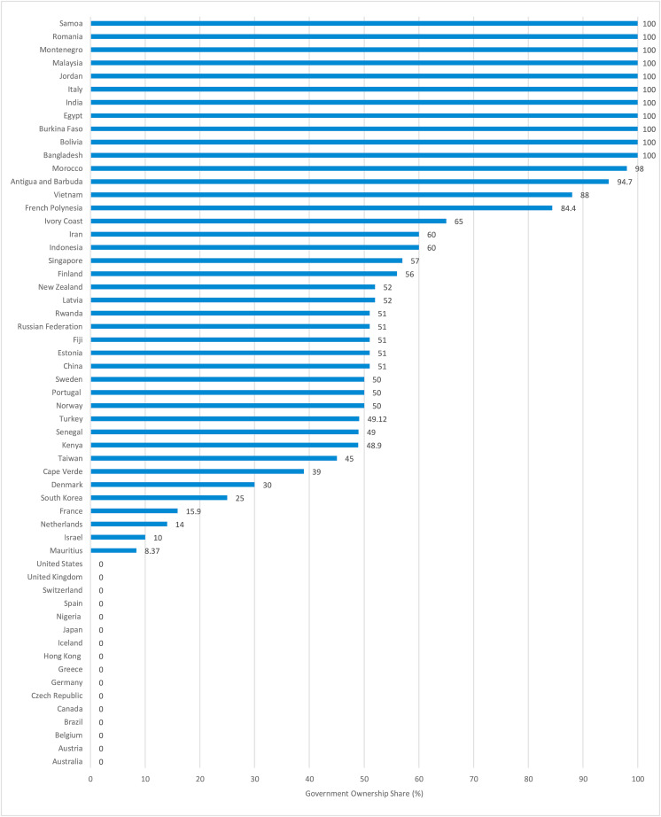](https://www.ncbi.nlm.nih.gov/core/lw/2.0/html/tileshop_pmc/tileshop_pmc_inline.html?title=Click%20on%20image%20to%20zoom&p=PMC3&id=7489892_gr9_lrg.jpg)](https://www.ncbi.nlm.nih.gov/core/lw/2.0/html/tileshop_pmc/tileshop_pmc_inline.html?title=Click%20on%20image%20to%20zoom&p=PMC3&id=7489892_gr9_lrg.jpg" \t "tileshopwindow)

[Open in a separate window](https://www.ncbi.nlm.nih.gov/pmc/articles/PMC7489892/figure/fig9/?report=objectonly)

[Fig. 9](https://www.ncbi.nlm.nih.gov/pmc/articles/PMC7489892/figure/fig9/)

Government ownership (in %) of airlines in countries with confirmed or reported Government support.

Source: Authors' calculations using airline websites.

Whether private ownership is preferable to public ownership in economic terms, however, depends on the extent of market power controlled by the privatised firms ([Megginson and Netter (2001)](https://www.ncbi.nlm.nih.gov/pmc/articles/PMC7489892/" \l "bib46), [Estache, 2001](https://www.ncbi.nlm.nih.gov/pmc/articles/PMC7489892/" \l "bib21); [Megginson and Netter (2001)](https://www.ncbi.nlm.nih.gov/pmc/articles/PMC7489892/" \l "bib46);[Winston, 2013](https://www.ncbi.nlm.nih.gov/pmc/articles/PMC7489892/#bib69)). Under competitive market conditions, government ownership is not inherently less efficient than private ownership. The existing evidence suggests that competition is the key to efficiency rather than private ownership by itself. In markets with monopoly elements, such as the airline industry, the main factor that appears to be at work is regulatory policy ([Estrin and Pelletier, 2018](https://www.ncbi.nlm.nih.gov/pmc/articles/PMC7489892/#bib22); [Oum et al., 2006](https://www.ncbi.nlm.nih.gov/pmc/articles/PMC7489892/" \l "bib56)).

Using the ‘efficiency gain’ argument for privatisation during the unprecedented COVID-19 crisis is difficult when the biggest concern is the survival of all airlines alike. As governments are called on as the last resort, the overriding concern should not be the reversal of privatisation by itself, but the transparency of ownership change, and most importantly the survival of competition policies and principles that ensure privatisation delivers on its promises.

The current crisis has pushed several government-owned-airlines over the edge towards bankruptcy and painful but much needed restructuring, thereby creating a good opportunity for the privatisation of airlines. However, due to the severity of the current shock and the deep uncertainty around the shape and speed of economic recovery, whether the private sector can come to the rescue is still doubtful. Even if it does, governments need to balance their obligations of ensuring basic and/or essential connectivity vis-à-vis the desire to attract private capital. Whilst there are concerns that commercially focused airlines could lead to insufficient and less reliable services, government ownership of carriers is not necessarily the way to ensure connectivity and advance economic policies. The desire to access private sector capital and its expertise needs to be balanced against governments’ desire to use airlines as an extension of their economic policy (such as maintaining domestic and international connectivity, export promotion, amongst others).

### 3.3. Implications on sustainability

Air transport is often considered to be one of the greenhouse gas emitting sectors that is the least involved in mitigating climate and environmental impacts. According to [ATAG (2019)](https://www.ncbi.nlm.nih.gov/pmc/articles/PMC7489892/#bib6) the aviation sector has been successful in improving its fuel efficiency by a yearly rate of 2.3%, which was stronger than the industry target of 1.5% per annum from 2009 to 2020. [Graver, Zhang, and Rutherford (2019)](https://www.ncbi.nlm.nih.gov/pmc/articles/PMC7489892/#bib31) estimated that total CO2 emissions from all commercial operations, including passenger movement, belly freight and dedicated freight, totalled 918 million metric tons in 2018 made up of 40% domestic and 60% international trips. This figure equalled to 2.4% of the global CO2 emissions from fossil fuel use. Despite this small share in the CO2 emissions global contribution, the growth of the sector's CO2 emissions was fast, i.e. 32% between 2013 and 2018, which was 70% higher than assumed under ICAO projections. [UNFCCC (2014)](https://www.ncbi.nlm.nih.gov/pmc/articles/PMC7489892/#bib65) estimated that emissions from international air traffic grew by over 75% between 1990 and 2012, which was almost double the average emissions growth rate from all other economic sectors ([Transport and Environment, 2016](https://www.ncbi.nlm.nih.gov/pmc/articles/PMC7489892/#bib62)). Aviation is exempt from fuel tax, especially in international air trips. This fuel tax exemption is allowed by the 1944 ICAO Chicago Convention Article 24 which is still used as the main legal reference.

Despite reduced emissions and environmental impacts caused by air travel restriction policies during the COVID-19 period, the pandemic has put several aviation-related climate and environmental deals and agreements at risk. The carbon price in the European Union Emission Trading Scheme that includes aviation has dropped severely. As of March 25, 2020, the price dropped by almost 40% to a near 2-year low just above €15/ton CO2 ([Van den plas, 2020](https://www.ncbi.nlm.nih.gov/pmc/articles/PMC7489892/#bib67)), rebounding to €22/ton CO2 by June. Another example is the Carbon Offsetting and Reduction Scheme for International Aviation (CORSIA) scheme where the 2019–2020 CO2 emission level should be used as the baseline to calculate future CO2 emission reduction targets. However, significant drop in CO2 emissions in 2020 caused by the pandemic related Carbon Offsetting and Reduction Scheme for International Aviation air travel restriction would signify a very ambitious CO2 emission reduction target. In its position paper, [IATA (2020b)](https://www.ncbi.nlm.nih.gov/pmc/articles/PMC7489892/#bib36) asked the ICAO to use the 2019 CO2 emissions figures as the CORSIA baseline instead of using the average 2019–2020 figures. This can be considered as a negative sign from the sustainability point of view since the air transport industry would adopt less ambitious targets than it should.

Hepburn et al. (2020) performed a survey of over 231 leading economists (from 53 countries) including senior finance ministry and central bank officials and asked them about 25 different stimulus policies. They found that non-conditional airline bailouts have the lowest perceived economic payoff and the lowest overall desirability and concluded that conceivably these policymakers were put off by the industry's carbon emissions and perceptions of history repeating itself.

[O'Callaghan and Hepburn (2020)](https://www.ncbi.nlm.nih.gov/pmc/articles/PMC7489892/#bib52) suggested that each bailout should include conditions that the airline reach net-zero carbon emissions by 2050, with interim targets and a plan to deliver. Except for the Air France case, [Mariz (2020b)](https://www.ncbi.nlm.nih.gov/pmc/articles/PMC7489892/" \l "bib45) and [Keating (2020)](https://www.ncbi.nlm.nih.gov/pmc/articles/PMC7489892/#bib39) noticed that all pandemic crisis-related bailouts currently received by airlines up to now are mostly without a ‘green condition’. [Vigoureux (2020)](https://www.ncbi.nlm.nih.gov/pmc/articles/PMC7489892/" \l "bib68) however, reported that the green measures in the Air France bailout, namely the deletion of flight routes where high-speed train services connect those two points in 2.5 h or less, fleet renewal obligation to reduce emissions, and a 2% biofuel mandatory use starting in 2025 were already in the pipeline before the pandemic. Whereas the French federation of climate action, [Réseau Action Climat (2020)](https://www.ncbi.nlm.nih.gov/pmc/articles/PMC7489892/" \l "bib60) pointed out that only flight abolishment on routes where high-speed train services can connect in 5 h of travel time or less shall make a meaningful environmental target.

Hepburn et al. (2020) stated that many Group of 20 (G20) national governments have already proposed and/or implemented sizeable fiscal rescue measures to protect balance sheets, reduce bankruptcies, and address immediate human welfare concerns during lockdown periods. For developing countries, [Ing and Vadila (2020)](https://www.ncbi.nlm.nih.gov/pmc/articles/PMC7489892/" \l "bib34) remarked that the main issues caused by this pandemic are rising poverty and youth unemployment.

However, some rescue policies also cover emissions-intensive firms, such as airlines, that face bankruptcy or significantly reduced revenue resulting from the pandemic. Examples include the Russian Federation's tax deferrals for airlines ([Ostapets et al., 2020](https://www.ncbi.nlm.nih.gov/pmc/articles/PMC7489892/" \l "bib55)), AU$715 million of unconditional Australian airline relief (through the Coronavirus Economic Response Package ([Commonwealth of Australia, 2020](https://www.ncbi.nlm.nih.gov/pmc/articles/PMC7489892/#bib16)), EUROCONTROL member states' agreement to release a financial package enabling airlines to defer payment of up to €1.1 billion of air traffic control fees due for payment to Europe's air traffic management industry ([EUROCONTROL, 2020](https://www.ncbi.nlm.nih.gov/pmc/articles/PMC7489892/#bib23)), and US$32 billion in bailouts (including grants and loans) for US airlines (through the CARES Act) ([Courtney, 2020](https://www.ncbi.nlm.nih.gov/pmc/articles/PMC7489892/#bib17)). Furthermore, as reported in [Morgan (2020)](https://www.ncbi.nlm.nih.gov/pmc/articles/PMC7489892/#bib48), some airlines have asked that plans to levy green taxes on aviation should be postponed because of the economic impact caused by the COVID-19 pandemic and to reduce the existing ones.

Whilst political and other circumstances related to the national interest may render some climate-negative policies unavoidable, even these policies can be designed to have long-term positive climate outcomes by attaching appropriate conditions. For instance, [O'Callaghan and Hepburn (2020)](https://www.ncbi.nlm.nih.gov/pmc/articles/PMC7489892/#bib52) suggested that each bailout should include conditions that the airline reach net-zero carbon emissions by 2050 with intermediate targets set at 5- or 10-year intervals. If airlines are unable to meet these targets, bailout funding would be converted to equity at current low stock market prices. In this way, airline executives and shareholders would have strong financial incentives to meet carbon reduction targets, governments would improve their progress to meeting international climate commitments, and the world would benefit from slowed global warming. France and Germany have already included environmental targets as part of the conditions of government support to Air France and Lufthansa respectively.

Finally, there are at least two other indirect impacts of bailouts that can affect sustainability where in-depth analysis might be needed in the future. First, bailouts might induce some airlines to consolidate their route operations by increasing the use of hubs and reducing point-to-point flight connections that would increase the distance per air trip and therefore increase energy use and emissions. Some trends towards this kind of consolidation already can be seen in the United States as reported for example by [Le Beau (2020)](https://www.ncbi.nlm.nih.gov/pmc/articles/PMC7489892/#bib41) and [Slotnick (2020)](https://www.ncbi.nlm.nih.gov/pmc/articles/PMC7489892/" \l "bib61). Second, airlines might deviate some of their aircrafts flying routes to take advantage of air navigation service providers (ANSP) or air space implementing lower en-route unit rates or to avoid air space applying higher rates. The en-route unit rate might change as a direct or indirect result of the different bailout policies taken by different governments to support ANSP or air space under their jurisdiction. The route deviation might reduce the horizontal flight efficiency and therefore increase their fuel use. [IATA (2020c)](https://www.ncbi.nlm.nih.gov/pmc/articles/PMC7489892/#bib37), reported that the Russian Federation's Civil Aviation Authority announced significant reductions in ANSP charges for Russian carriers from March 17, 2020 until October 1, 2020, with some measures for the Russian Federation's Far Eastern Federal District. On the other hand, [Champion-Smith (2020)](https://www.ncbi.nlm.nih.gov/pmc/articles/PMC7489892/#bib13) reported that Nav Canada has proposed increasing air traffic control charges, including the en-route unit rate, from September 2020 onwards by nearly 30% as a result of less revenue caused by the Covid-19 pandemic.

[Go to:](https://www.ncbi.nlm.nih.gov/pmc/articles/PMC7489892/)

## 4. Conclusions

The disruptions caused by the COVID-19 pandemic could affect the aviation sector for much longer than the duration of the emergency. Risk aversion and self-imposed social distancing can modify current trends in aviation demand and user choices. A possible economic slowdown can further complicate the demand and supply of aviation services, as well as investment and innovation in the sector. Several airlines, airports, and other aviation-related operators have lost a significant part of their income since mid-March 2020, raising worries about their financial stability and their capacity to recover their services. Many such operators will potentially require direct or indirect government support, which can distort the competition landscape at domestic and international levels.

The need for support and the actual support to airlines provided by governments vary significantly in each country. Our analysis suggests that most governments give a high priority to maintaining air transport connectivity in order to protect economic activity and jobs, in aviation itself and in related sectors such as tourism. This often means that the support is primarily given to, at best, a handful of national operators in each country, which were already enjoying preferential treatment compared to the competition. Large domestic operators — helped by an uncompetitive domestic market — provide national firms with economies of scale, which in turn allow them to compete for the market share and profits in international markets. The historical, political, geographic, and operational reasons that in the past led to the formation of national and regional oligopolies in aviation have led to a path dependency. The players participating in the oligopolistic market have become ‘too big to fail’ and government intervention is considered unavoidable. Government support as a reaction to the pandemic will most probably reinforce the role of national champions and allow them to gain a higher market share to the detriment of smaller players who cannot attract as much private or public financing. Consequently, the competition landscape – and its impacts on fares and supply for travel services – would suffer a distortion.

Either due to the direct financial repercussions of the pandemic itself, or as a result of the increased market concentration, the levels of air transport connectivity reached in 2019 will probably not recover soon. Several unprofitable routes and airlines may disappear in the short term and will only be able to recover or be substituted by new players when overall market conditions permit it. From the connectivity point of view, government support is the pragmatic approach that ensures at least a partial mitigation of the impacts. Big markets with a strong government financial position can preserve their connectivity more effectively than smaller markets in less-developed countries. A domino effect of government support to protect the competitiveness of their national public and private airlines can be expected, leading to imbalances in air transport connectivity at international level.

The trade-off between ensuring connectivity and maintaining competition after the COVID-19 pandemic is a challenge with several political and economic dimensions. Government support can be, however, also an opportunity for improving certain aspects of the air transport industry. The example of the approval of support to Lufthansa by the German government under specific conditions imposed by the European Commission may be an option to follow in other cases too. Lufthansa is obliged to free a number of slots in its Frankfurt and Munich hubs for potential use by competitors and remove a number of aircraft from its fleet, in order to partially rebalance the disequilibrium in competition that aiding the airline would cause.

The re-orientation of public policy in the aftermath of the pandemic may limit the relative importance of the policy priorities that shaped the evolution of the air transport sector before the crisis, especially those related to climate change and the environment. The role of government and public authorities at all levels – especially the type and duration of measures affecting transport operations – will be crucial for the future development of the aviation industry. Sustainability criteria, used as one condition for government support to airlines, can be compatible with a post-pandemic strategy for the aviation sector. Guiding the support to air transport operators towards technologies and operational models that meet wider policy priorities is an option that can deliver longer-term benefits. In that sense, government support that results in partial or full nationalisation of carriers can be positive, since it may be a lever to introduce social and environmental goals.

[Go to:](https://www.ncbi.nlm.nih.gov/pmc/articles/PMC7489892/)

## Author statement

**Megersa Abate:** Conceptualization, Methodology, Data curation, Software, Visualization, Writing- Original draft preparation, Writing- Reviewing and Editing.

**Panayotis Christidis**: Conceptualization, Methodology, Data curation, Writing- Original draft preparation, Writing- Reviewing and Editing.

**Alloysius Joko Purwanto:** Conceptualization, Methodology, Data curation, Writing- Original draft preparation, Writing- Reviewing and Editing.

[Go to:](https://www.ncbi.nlm.nih.gov/pmc/articles/PMC7489892/)

## Disclaimer

The opinions expressed in this paper are those of the authors and do not reflect the official position of the World Bank, the European Commission, or the Economics Research Institute for ASEAN and East Asia.

[Go to:](https://www.ncbi.nlm.nih.gov/pmc/articles/PMC7489892/)

## Footnotes

☆**Disclaimer**: The opinions expressed in this paper are those of the authors and do not reflect the official position of the World Bank, the European Commission, or the Economics Research Institute for ASEAN and East Asia.

1Alternative models such as the Tobit and Heckman Sample Selection model were tried but didn't give robust and intuitive results. From the viewpoint of interpretation, the two-part model is flexible and attractive because it allows different covariates to have a different impact on the two parts of the model. In addition to giving plausible coefficient estimates, the two-part model fitted our sample better as evidenced by a higher log likelihood value.

2The share of the travel and transport industry in the services export of a country can also shed light on the extent to which a country's financial support is targeted at addressing the vulnerabilities the air transport sector and its direct beneficiaries are facing. Figure\_Apx 1 in the Appendix presents the most vulnerable countries across these dimensions globally.

3Honk Kong, the Netherland and Rwanda don't appear in [Fig. 5](https://www.ncbi.nlm.nih.gov/pmc/articles/PMC7489892/figure/fig5/) for ease of presentation, but they indeed appear at the top right corner.

Appendix ASupplementary data to this article can be found online at <https://doi.org/10.1016/j.jairtraman.2020.101931>.

[Go to:](https://www.ncbi.nlm.nih.gov/pmc/articles/PMC7489892/)

## Appendix

International Air Transport Dependence (vulnerability) Measures

### Figure Apx 1

[[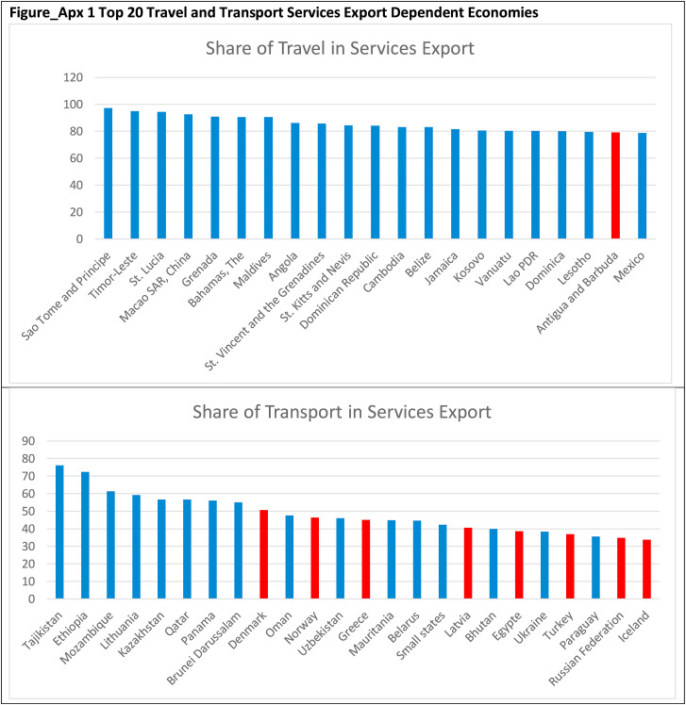](https://www.ncbi.nlm.nih.gov/core/lw/2.0/html/tileshop_pmc/tileshop_pmc_inline.html?title=Click%20on%20image%20to%20zoom&p=PMC3&id=7489892_fx1_lrg.jpg)](https://www.ncbi.nlm.nih.gov/core/lw/2.0/html/tileshop_pmc/tileshop_pmc_inline.html?title=Click%20on%20image%20to%20zoom&p=PMC3&id=7489892_fx1_lrg.jpg" \t "tileshopwindow)

[Open in a separate window](https://www.ncbi.nlm.nih.gov/pmc/articles/PMC7489892/figure/dfig1/?report=objectonly)

Top 20 Travel and Transport Services Export Dependent Economies.

Source: Authors based on WDI data. Countries in red have reported government support.

Country ISO3 Codes.

| **Country Name** | **ISO3** | **Country Name** | **ISO3** | **Country Name** | **ISO3** |
| --- | --- | --- | --- | --- | --- |
| Algeria | DZA | Greece | GRC | Qatar | QAT |
| Angola | AGO | Guatemala | GTM | Romania | ROU |
| Antigua and Barbuda | ATG | Hong Kong | HKG | Russian Federation | RUS |
| Argentina | ARG | Iceland | ISL | Rwanda | RWA |
| Armenia | ARM | India | IND | Samoa | WSM |
| Australia | AUS | Indonesia | IDN | Saudi Arabia | SAU |
| Austria | AUT | Iran | IRN | Senegal | SEN |
| Azerbaijan | AZE | Ireland | IRL | Serbia | SRB |
| Bahamas | BHS | Israel | ISR | Seychelles | SYC |
| Bangladesh | BGD | Italy | ITA | Singapore | SGP |
| Belarus | BLR | Ivory Coast | CIV | South Africa | ZAF |
| Belgium | BEL | Japan | JPN | South Korea | KOR |
| Bolivia | BOL | Jordan | JOR | Spain | ESP |
| Brazil | BRA | Kazakhstan | KAZ | Sri Lanka | LKA |
| Burkina Faso | BFA | Kenya | KEN | Sudan | SDN |
| Cameroon | CMR | Latvia | LVA | Sweden | SWE |
| Canada | CAN | Madagascar | MDG | Switzerland | CHE |
| Cape Verde | CPV | Malaysia | MYS | Taiwan | TWN |
| Chile | CHL | Mauritius | MUS | Thailand | THA |
| China | CHN | Mexico | MEX | Togo | TGO |
| Colombia | COL | Montenegro | MNE | Trinidad Tobago | TTO |
| Congo, Rep. | COG | Morocco | MAR | Tunisia | TUN |
| Cost Rica | COD | Mozambique | MOZ | Turkey | TUR |
| Croatia | HRV | Myanmar | MMR | UAE | ARE |
| Czech Republic | CZE | Namibia | NAM | Ukraine | UKR |
| Denmark | DNK | Nepal | NPL | United Kingdom | GBR |
| Egypt | EGY | Netherlands | NLD | United States | USA |
| Estonia | EST | New Zealand | NZL | Uzbekistan | UZB |
| Ethiopia | ETH | Nigeria | NGA | Vietnam | VNM |
| Fiji | FJI | Norway | NOR |  |  |
| Finland | FIN | Pakistan | PAK |  |  |
| France | FRA | Panama | PAN |  |  |
| French Polynesia | PYF | Peru | PER |  |  |
| Georgia | GEO | Philippines | PHL |  |  |
| Germany | DEU | Poland | POL |  |  |
| Ghana | GHA | Portugal | PRT |  |  |

[Open in a separate window](https://www.ncbi.nlm.nih.gov/pmc/articles/PMC7489892/table/undtbl1/?report=objectonly)

[Go to:](https://www.ncbi.nlm.nih.gov/pmc/articles/PMC7489892/)

## Appendix A. Supplementary data

The following is the Supplementary data to this article:

**Multimedia component 1:**

[Click here to view.](https://www.ncbi.nlm.nih.gov/pmc/articles/PMC7489892/bin/mmc1.xml)(206 bytes, xml)Multimedia component 1

[Go to:](https://www.ncbi.nlm.nih.gov/pmc/articles/PMC7489892/)

## References

1. Abate M. Economic effects of air transport market liberalization in Africa. *Transport. Res. Pol. Pract.*2016;92:326–337. doi: 10.1016/j.tra.2016.06.014. [[CrossRef](https://dx.doi.org/10.1016%2Fj.tra.2016.06.014" \t "_blank)] [[Google Scholar](https://scholar.google.com/scholar_lookup?journal=Transport.+Res.+Pol.+Pract.&title=Economic+effects+of+air+transport+market+liberalization+in+Africa&author=M.+Abate&volume=92&publication_year=2016&pages=326-337&doi=10.1016/j.tra.2016.06.014&)]
2. Abate M., Christidis P. The impact of air transport market liberalization: evidence from EU's external aviation policy. *Econ. Transport.*2020;22 doi: 10.1016/j.ecotra.2020.100164. [[CrossRef](https://dx.doi.org/10.1016%2Fj.ecotra.2020.100164" \t "_blank)] [[Google Scholar](https://scholar.google.com/scholar_lookup?journal=Econ.+Transport.&title=The+impact+of+air+transport+market+liberalization:+evidence+from+EU%27s+external+aviation+policy&author=M.+Abate&author=P.+Christidis&volume=22&publication_year=2020&doi=10.1016/j.ecotra.2020.100164&" \t "_blank)]
3. Adler N., Fu X., Oum T.H., Yu C. Air transport liberalization and airport slot allocation: the case of the Northeast asian transport market. *Transport. Res. Pol. Pract.*2014;62:3–19. [[Google Scholar](https://scholar.google.com/scholar_lookup?journal=Transport.+Res.+Pol.+Pract.&title=Air+transport+liberalization+and+airport+slot+allocation:+the+case+of+the+Northeast+asian+transport+market&author=N.+Adler&author=X.+Fu&author=T.H.+Oum&author=C.+Yu&volume=62&publication_year=2014&pages=3-19&" \t "_blank)]
4. Al-Jazzaf M.I. Impact of privatization on airlines performance: an empirical analysis. *J. Air Transport. Manag.*1999;5(1):45–52. Elsevier. [[Google Scholar](https://scholar.google.com/scholar_lookup?journal=J.+Air+Transport.+Manag.&title=Impact+of+privatization+on+airlines+performance:+an+empirical+analysis&author=M.I.+Al-Jazzaf&volume=5&issue=1&publication_year=1999&pages=45-52&" \t "_blank)]
5. Andrew D., Juan E.J. Air transport infrastructure: the roles of the public and private sector. 2005. <http://pubdocs.worldbank.org/en/317661434652909047/Air-Transport-infrastructure.pdf>
6. Air Transport Action Group ATAG Fact sheet #3 – tracking aviation efficiency. 2019. <https://aviationbenefits.org/media/166506/fact-sheet_3_tracking-aviation-efficiency.pdf>
7. Backx M., Carney M., Gedajlovic E. Public, private and mixed ownership and the performance of international airlines. *J. Air Transport. Manag.*2002;8(4):213–220. <https://www.sciencedirect.com/science/article/abs/pii/S0969699701000539> [[Google Scholar](https://scholar.google.com/scholar_lookup?journal=J.+Air+Transport.+Manag.&title=Public,+private+and+mixed+ownership+and+the+performance+of+international+airlines&author=M.+Backx&author=M.+Carney&author=E.+Gedajlovic&volume=8&issue=4&publication_year=2002&pages=213-220&)]
8. Borenstein S., Rose N.L. *NBER Working Paper.* National Bureau of Economic Research; 2007. How airline markets work… or do they? Regulatory reform in the airline industry. No. 13452. [[Google Scholar](https://scholar.google.com/scholar_lookup?title=NBER+Working+Paper&author=S.+Borenstein&author=N.L.+Rose&publication_year=2007&" \t "_blank)]
9. Brueckner J.K., Lee D., Singer E.S. Airline competition and domestic US airfares: a comprehensive reappraisal. *Econ. Transport.*2013;2(1):1–17. [[Google Scholar](https://scholar.google.com/scholar_lookup?journal=Econ.+Transport.&title=Airline+competition+and+domestic+US+airfares:+a+comprehensive+reappraisal&author=J.K.+Brueckner&author=D.+Lee&author=E.S.+Singer&volume=2&issue=1&publication_year=2013&pages=1-17&" \t "_blank)]
10. Burghouwt G., de Wit J.G. In the wake of liberalisation: long-term developments in the EU air transport market. *Transport Pol.*2015;43:104–113. [[Google Scholar](https://scholar.google.com/scholar_lookup?journal=Transport+Pol.&title=In+the+wake+of+liberalisation:+long-term+developments+in+the+EU+air+transport+market&author=G.+Burghouwt&author=J.G.+de+Wit&volume=43&publication_year=2015&pages=104-113&" \t "_blank)]
11. CAPA . CAPA Centre for Aviation; Sydney, Australia: 2014. ‘European Air Transport Competitiveness. CAPA Contributes to the Debate at ECAC/EU Dialog’, 11 July.<http://centreforaviation.com/analysis/european-air-transport-competitiveness-capa-contributes-to-the-debate-at-ecaceu-diaLnue-176666> [[Google Scholar](https://scholar.google.com/scholar?q=CAPA+%E2%80%98European+Air+Transport+Competitiveness.+CAPA+Contributes+to+the+Debate+at+ECAC/EU+Dialog%E2%80%99,+11+July+2014+CAPA+Centre+for+Aviation+Sydney,+Australia+http://centreforaviation.com/analysis/european-air-transport-competitiveness-capa-contributes-to-the-debate-at-ecaceu-diaLnue-176666+)]
12. CAPA . CAPA Centre for Aviation; Sydney, Australia: 2016. ‘CASK: Europe's Full Service Airlines Have the World's Highest Costs, US Airlines the Lowest’, 1 June.<http://centreforaviation.com/analysis/iata-cask-europes-full-service-airlines-have-the-worlds-highest-us-airlines-the-lowest-281609> [[Google Scholar](https://scholar.google.com/scholar?q=CAPA+%E2%80%98CASK:+Europe%27s+Full+Service+Airlines+Have+the+World%27s+Highest+Costs,+US+Airlines+the+Lowest%E2%80%99,+1+June+2016+CAPA+Centre+for+Aviation+Sydney,+Australia+http://centreforaviation.com/analysis/iata-cask-europes-full-service-airlines-have-the-worlds-highest-us-airlines-the-lowest-281609+)]
13. Champion-Smith B. As COVID-19 grounds travellers, Canada's air traffic control agency is hiking airline fees by 30 per cent. 2020. <https://www.thestar.com/politics/federal/2020/05/20/as-covid-19-grounds-travellers-canadas-air-traffic-control-agency-is-hiking-airline-fees-by-30-per-cent.html> The Star, 20 May.
14. Charlton A. Coronavirus crisis is an opportunity to remake the airline industry. 2020. <https://www.forbes.com/sites/andrewcharlton5/2020/03/15/aviation-everything-is-up-in-the-air/#661b38ba463a> Forbes, 15 March.
15. Christidis P. Four shades of open skies: European union and four main external partners. *J. Transport Geogr.*2016;50:105–114. doi: 10.1016/j.jtrangeo.2015.04.005. [[CrossRef](https://dx.doi.org/10.1016%2Fj.jtrangeo.2015.04.005" \t "_blank)] [[Google Scholar](https://scholar.google.com/scholar_lookup?journal=J.+Transport+Geogr.&title=Four+shades+of+open+skies:+European+union+and+four+main+external+partners&author=P.+Christidis&volume=50&publication_year=2016&pages=105-114&doi=10.1016/j.jtrangeo.2015.04.005&" \t "_blank)]
16. Commonwealth of Australia . Commonwealth of Australia; Canberra: 2020. Coronavirus Economic Response Package Omnibus Bill 2020 (Schedule 7, Part 2) [[Google Scholar](https://scholar.google.com/scholar?q=Commonwealth+of+Australia+Coronavirus+Economic+Response+Package+Omnibus+Bill+2020+(Schedule+7,+Part+2)+2020+Commonwealth+of+Australia+Canberra+)]
17. Courtney J. CARES Act. 2020. <https://www.congress.gov/bill/116th-congress/senate-bill/3548/text?q=product+actualizaci%C3%B3n> vol. 116.
18. Cristea A.D., Hillberry R., Mattoo A. Open skies over the Middle East. *World Econ.*2015;38(11):1650–1681. [[Google Scholar](https://scholar.google.com/scholar_lookup?journal=World+Econ.&title=Open+skies+over+the+Middle+East&author=A.D.+Cristea&author=R.+Hillberry&author=A.+Mattoo&volume=38&issue=11&publication_year=2015&pages=1650-1681&" \t "_blank)]
19. De Poret M., O'Connell J.F., Warnock-Smith D. The economic viability of long-haul low cost operations: evidence from the transatlantic market. *J. Air Transport. Manag.*2015;42:272–281. doi: 10.1016/j.jairtraman.2014.11.007. January. [[CrossRef](https://dx.doi.org/10.1016%2Fj.jairtraman.2014.11.007" \t "_blank)] [[Google Scholar](https://scholar.google.com/scholar_lookup?journal=J.+Air+Transport.+Manag.&title=The+economic+viability+of+long-haul+low+cost+operations:+evidence+from+the+transatlantic+market&author=M.+De+Poret&author=J.F.+O%27Connell&author=D.+Warnock-Smith&volume=42&publication_year=2015&pages=272-281&doi=10.1016/j.jairtraman.2014.11.007&)]
20. Dresner M., Eroglu C., Hofer C., Mendez F., Tan K. The impact of Gulf carrier competition on U.S. Airlines. *Transport. Res. Pol. Pract.*2015;79:31–41. [[Google Scholar](https://scholar.google.com/scholar_lookup?journal=Transport.+Res.+Pol.+Pract.&title=The+impact+of+Gulf+carrier+competition+on+U.S.+Airlines&author=M.+Dresner&author=C.+Eroglu&author=C.+Hofer&author=F.+Mendez&author=K.+Tan&volume=79&publication_year=2015&pages=31-41&" \t "_blank)]
21. Estache A. Privatization and regulation of transport infrastructure in the 1990s. *World Bank Res. Obs.*2001;16(1):85–107. <http://documents.worldbank.org/curated/en/994171468336659313/pdf/766580JRN0WBRO00Box374385B00PUBLIC0.pdf> [[Google Scholar](https://scholar.google.com/scholar_lookup?journal=World+Bank+Res.+Obs.&title=Privatization+and+regulation+of+transport+infrastructure+in+the+1990s&author=A.+Estache&volume=16&issue=1&publication_year=2001&pages=85-107&)]
22. Estrin S., Pelletier A. Privatization in developing countries: what are the lessons of recent experience? *World Bank Res. Obs.*2018;33(1):65–102. [[Google Scholar](https://scholar.google.com/scholar_lookup?journal=World+Bank+Res.+Obs.&title=Privatization+in+developing+countries:+what+are+the+lessons+of+recent+experience?&author=S.+Estrin&author=A.+Pelletier&volume=33&issue=1&publication_year=2018&pages=65-102&" \t "_blank)]
23. EUROCONTROL . Press Release; 2020. EUROCONTROL States Agree a €1.1 Billion Deferral Package to Assist Airlines.<https://www.eurocontrol.int/press-release/eurocontrol-states-assist-airlines-11bln-deferral> 7 April 2020. [[Google Scholar](https://scholar.google.com/scholar?q=EUROCONTROL+EUROCONTROL+States+Agree+a+%E2%82%AC1.1+Billion+Deferral+Package+to+Assist+Airlines+2020+Press+Release+7+April+2020+https://www.eurocontrol.int/press-release/eurocontrol-states-assist-airlines-11bln-deferral+)]
24. European Commission . Policy Brief; 2020. Future of Transport: Update on the Economic Impacts of COVID-19.<https://ec.europa.eu/jrc/sites/jrcsh/files/202005_future_of_transport_covid_sfp.brief_.pdf> JRC120625. [[Google Scholar](https://scholar.google.com/scholar?q=European+Commission+Future+of+Transport:+Update+on+the+Economic+Impacts+of+COVID-19+2020+Policy+Brief+JRC120625+https://ec.europa.eu/jrc/sites/jrcsh/files/202005_future_of_transport_covid_sfp.brief_.pdf+)]
25. European Commission Communication from the commission: amendment to the temporary framework for state aid measures to support the economy in the current COVID-19 outbreak. 2020. <https://ec.europa.eu/competition/state_aid/what_is_new/sa_covid19_2nd_amendment_temporary_framework_en.pdf> 8 May.
26. Flightnook Team The impact of flying and its environmental challenges. 2017. <https://www.flightnook.com/2017the-impact-of-flying-and-its-environmental-challenges> 15 November.
27. Forsyth P., Guiomard C. The economic approach to subsidies for foreign airlines. *J. Air Transport. Manag.*2019;74:47–53. doi: 10.1016/j.jairtraman.2018.09.006. [[CrossRef](https://dx.doi.org/10.1016%2Fj.jairtraman.2018.09.006" \t "_blank)] [[Google Scholar](https://scholar.google.com/scholar_lookup?journal=J.+Air+Transport.+Manag.&title=The+economic+approach+to+subsidies+for+foreign+airlines&author=P.+Forsyth&author=C.+Guiomard&volume=74&publication_year=2019&pages=47-53&doi=10.1016/j.jairtraman.2018.09.006&)]
28. Goetz A., Vowles T. The good, the bad, and the ugly: 30 Years of US airline deregulation. *J. Transport Geogr.*2009;17:251–263. doi: 10.1016/j.jtrangeo.2009.02.012. [[CrossRef](https://dx.doi.org/10.1016%2Fj.jtrangeo.2009.02.012" \t "_blank)] [[Google Scholar](https://scholar.google.com/scholar_lookup?journal=J.+Transport+Geogr.&title=The+good,+the+bad,+and+the+ugly:+30+Years+of+US+airline+deregulation&author=A.+Goetz&author=T.+Vowles&volume=17&publication_year=2009&pages=251-263&doi=10.1016/j.jtrangeo.2009.02.012&" \t "_blank)]
29. Gössling S., Ceron J.-P., Dubois G., Hall C.M. Hypermobile travellers. In: Gössling S., Upham P., editors. *Climate Change and Aviation.* Earthscan; London: 2009. [[Google Scholar](https://scholar.google.com/scholar_lookup?title=Climate+Change+and+Aviation&author=S.+G%C3%B6ssling&author=J.-P.+Ceron&author=G.+Dubois&author=C.M.+Hall&publication_year=2009&" \t "_blank)]
30. Gössling S., Fichert F., Forsyth P., Niemeier H.-M. Subsidies in aviation. *Sustainability.*2017;9(8):1295. doi: 10.3390/su9081295. [[CrossRef](https://dx.doi.org/10.3390%2Fsu9081295" \t "_blank)] [[Google Scholar](https://scholar.google.com/scholar_lookup?journal=Sustainability&title=Subsidies+in+aviation&author=S.+G%C3%B6ssling&author=F.+Fichert&author=P.+Forsyth&author=H.-M.+Niemeier&volume=9&issue=8&publication_year=2017&pages=1295&doi=10.3390/su9081295&" \t "_blank)]
31. Graver B., Zhang K., Rutherford D. International Council on Clean Transportation Working Paper; 2019. CO2 Emissions from Commercial Aviation, 2018. [[Google Scholar](https://scholar.google.com/scholar?q=Graver+B.+Zhang+K.+Rutherford+D.+CO+2++Emissions+from+Commercial+Aviation,+2018+2019+International+Council+on+Clean+Transportation+Working+Paper+" \t "_blank)]
32. Harvey & Turnbull On the Go: walking the high road at a low cost airline. *Int. J. Hum. Resour. Manag.*2010;21(2):230–241. doi: 10.1080/09585190903509548. [[CrossRef](https://dx.doi.org/10.1080%2F09585190903509548" \t "_blank)] [[Google Scholar](https://scholar.google.com/scholar_lookup?journal=Int.+J.+Hum.+Resour.+Manag.&title=On+the+Go:+walking+the+high+road+at+a+low+cost+airline&author=+Harvey+&+Turnbull&volume=21&issue=2&publication_year=2010&pages=230-241&doi=10.1080/09585190903509548&" \t "_blank)]
33. Helm D. Thirty years after water privatization - is the English model the envy of the world? *Oxf. Rev. Econ. Pol.*2020;36(1) <http://www.dieterhelm.co.uk/assets/secure/documents/Thirty-years-after-water-privatisation-HELM.pdf> January. [[Google Scholar](https://scholar.google.com/scholar_lookup?journal=Oxf.+Rev.+Econ.+Pol.&title=Thirty+years+after+water+privatization+-+is+the+English+model+the+envy+of+the+world?&author=D.+Helm&volume=36&issue=1&publication_year=2020&" \t "_blank)]
34. ICAO . *International Civil Aviation Organization (ICAO). Worldwide Air Transport Conference, Sixth Meeting, Montréal, 18–22 March 2013.* 2013. Fair competition in international air transport. ATConf/6-WP/4, 4/12/12. [[Google Scholar](https://scholar.google.com/scholar_lookup?title=International+Civil+Aviation+Organization+(ICAO).+Worldwide+Air+Transport+Conference,+Sixth+Meeting,+Montr%C3%A9al,+18%E2%80%9322+March+2013&publication_year=2013&)]
35. Ing L.Y., Vadila Y. East Asia Forum Quarterly; 2020. ‘Implementing Indonesia's COVID-19 Stimulus,’ pp. 27–28.<https://press-files.anu.edu.au/downloads/press/n6974/pdf/book.pdf> April–June. [[Google Scholar](https://scholar.google.com/scholar?q=Ing+L.Y.+Vadila+Y.+%E2%80%98Implementing+Indonesia%27s+COVID-19+Stimulus,%E2%80%99+2020+East+Asia+Forum+Quarterly+27+28+April%E2%80%93June+https://press-files.anu.edu.au/downloads/press/n6974/pdf/book.pdf+)]
36. International Air Transport Association . 2020. Industry Losses to Top $84 Billion in 2020.<https://www.iata.org/en/pressroom/pr/2020-06-09-01/> [[Google Scholar](https://scholar.google.com/scholar?q=International+Air+Transport+Association+Industry+Losses+to+Top+$84+Billion+in+2020+2020+https://www.iata.org/en/pressroom/pr/2020-06-09-01/+" \t "_blank)]
37. International Air Transport Association . IATA Position Paper; 2020. Impact of COVID-19 on CORSIA Baseline Calculation.<https://www.eraa.org/system/files/corsia_covid_position_paper_on_baseline_25_march_2020.pdf> 25 March. [[Google Scholar](https://scholar.google.com/scholar?q=International+Air+Transport+Association+Impact+of+COVID-19+on+CORSIA+Baseline+Calculation+2020+IATA+Position+Paper+25+March+https://www.eraa.org/system/files/corsia_covid_position_paper_on_baseline_25_march_2020.pdf+)]
38. International Air Transport Association Aviation charges intelligence center, temporary aviation charges measures. 2020. <https://aviationcharges.iata.org/covid19.xhtml>
39. InterVISTAS The economic impact of air service liberalization. 2014. <http://www.intervistas.com/downloads/Economic_Impact_of_Air_Service_Liberalization_Final_Report.pdf>
40. Keating D. Forbes.com; 2020. ‘EU Will Not Impose Green Conditions on Airline Bailouts’<https://www.forbes.com/sites/davekeating/2020/05/09/eu-will-not-impose-green-conditions-on-airline-bailouts/#6f14bc5e3180> 9 May. [[Google Scholar](https://scholar.google.com/scholar?q=Keating+D.+%E2%80%98EU+Will+Not+Impose+Green+Conditions+on+Airline+Bailouts%E2%80%99+2020+Forbes.com+9+May+https://www.forbes.com/sites/davekeating/2020/05/09/eu-will-not-impose-green-conditions-on-airline-bailouts/" \l "6f14bc5e3180+" \t "_blank)]
41. Knieps G. Market versus state in building the aviation value chain. *J. Air Transport. Manag.*2014;41:30–37. doi: 10.1016/j.jairtraman.2014.06.013. [[CrossRef](https://dx.doi.org/10.1016%2Fj.jairtraman.2014.06.013" \t "_blank)] [[Google Scholar](https://scholar.google.com/scholar_lookup?journal=J.+Air+Transport.+Manag.&title=Market+versus+state+in+building+the+aviation+value+chain&author=G.+Knieps&volume=41&publication_year=2014&pages=30-37&doi=10.1016/j.jairtraman.2014.06.013&)]
42. Le Beau P. CNBC; 2020. ‘Consolidating Flights to US Cities Could Help Stem Airline Industry Losses as Coronavirus Dampens Demand, Executives Say’<https://www.cnbc.com/2020/03/29/consolidating-flights-to-us-cities-could-help-stem-airline-losses.html> 29 March 29. [[Google Scholar](https://scholar.google.com/scholar?q=Le+Beau+P.+%E2%80%98Consolidating+Flights+to+US+Cities+Could+Help+Stem+Airline+Industry+Losses+as+Coronavirus+Dampens+Demand,+Executives+Say%E2%80%99+2020+CNBC+29+March+29+https://www.cnbc.com/2020/03/29/consolidating-flights-to-us-cities-could-help-stem-airline-losses.html+" \t "_blank)]
43. Leo D. What's behind the partnership between Singapore airlines and Malaysia airlines? 2019. <https://www.todayonline.com/commentary/whats-behind-partnership-between-singapore-airlines-and-malaysia-airlines>
44. Malina R., Albers S., Kroll N. Airport incentive programmes: a European perspective. *Transport Rev.*2012;32(4):435–453. doi: 10.1080/01441647.2012.684223. [[CrossRef](https://dx.doi.org/10.1080%2F01441647.2012.684223" \t "_blank)] [[Google Scholar](https://scholar.google.com/scholar_lookup?journal=Transport+Rev.&title=Airport+incentive+programmes:+a+European+perspective&author=R.+Malina&author=S.+Albers&author=N.+Kroll&volume=32&issue=4&publication_year=2012&pages=435-453&doi=10.1080/01441647.2012.684223&" \t "_blank)]
45. Mariz E. Covid-19 bailouts: Lufthansa in ‘advanced talks’ for bailout (21st May) 2020. <https://www.ishkaglobal.com/News/Article/6209/Covid-19-bailouts-Lufthansa-in-advanced-talks-for-bailout-21st-May> Ishka, 21 May.
46. Mariz E. String attached: how does covid-19 state aid constrain airlines? 2020. <https://www.ishkaglobal.com/News/Article/6215/Strings-attached-How-does-Covid-19-state-aid-constrain-airlines#IshkaDailyEmail?utm_medium=email&utm_campaign=website&utm_source=Daily+ishka> Ishka, 1 June.
47. Megginson W.L., Netter J.M. From state to market: a survey of empirical studies on privatization. *J. Econ. Lit.*2001;39(2):321–389. <https://www.aeaweb.org/articles?id=10.1257/jel.39.2.321> [[Google Scholar](https://scholar.google.com/scholar_lookup?journal=J.+Econ.+Lit.&title=From+state+to+market:+a+survey+of+empirical+studies+on+privatization&author=W.L.+Megginson&author=J.M.+Netter&volume=39&issue=2&publication_year=2001&pages=321-389&)]
48. Merkert R., Williams G. Determinants of European PSO airline efficiency - evidence from a semi-parametric approach. *J. Air Transport. Manag.*2013;29:11–16. doi: 10.1016/j.jairtraman.2012.12.002. [[CrossRef](https://dx.doi.org/10.1016%2Fj.jairtraman.2012.12.002" \t "_blank)] [[Google Scholar](https://scholar.google.com/scholar_lookup?journal=J.+Air+Transport.+Manag.&title=Determinants+of+European+PSO+airline+efficiency+-+evidence+from+a+semi-parametric+approach&author=R.+Merkert&author=G.+Williams&volume=29&publication_year=2013&pages=11-16&doi=10.1016/j.jairtraman.2012.12.002&)]
49. Morgan S. Euractiv.com; 2020. ‘Delay Aviation Tax Because of Coronavirus, Says Airlines Boss’<https://www.euractiv.com/section/aviation/news/delay-aviation-tax-because-of-coronavirus-says-airline-boss/> 4 March. [[Google Scholar](https://scholar.google.com/scholar?q=Morgan+S.+%E2%80%98Delay+Aviation+Tax+Because+of+Coronavirus,+Says+Airlines+Boss%E2%80%99+2020+Euractiv.com+4+March+https://www.euractiv.com/section/aviation/news/delay-aviation-tax-because-of-coronavirus-says-airline-boss/+" \t "_blank)]
50. Morrison W.G., de Wit J. US open skies agreements and unlevel playing fields. *J. Air Transport. Manag.*2019;74:30–38. doi: 10.1016/j.jairtraman.2018.09.004. [[CrossRef](https://dx.doi.org/10.1016%2Fj.jairtraman.2018.09.004" \t "_blank)] [[Google Scholar](https://scholar.google.com/scholar_lookup?journal=J.+Air+Transport.+Manag.&title=US+open+skies+agreements+and+unlevel+playing+fields&author=W.G.+Morrison&author=J.+de+Wit&volume=74&publication_year=2019&pages=30-38&doi=10.1016/j.jairtraman.2018.09.004&)]
51. Ng C.K., Seabright P. Competition, privatization and productive efficiency: evidence from the airline industry. *Econ. J.*2001;111(473):591–619. [[Google Scholar](https://scholar.google.com/scholar_lookup?journal=Econ.+J.&title=Competition,+privatization+and+productive+efficiency:+evidence+from+the+airline+industry&author=C.K.+Ng&author=P.+Seabright&volume=111&issue=473&publication_year=2001&pages=591-619&" \t "_blank)]
52. Njoya E.T., Christidis P., Nikitas A. ‘Understanding the impact of liberalisation in the EU–africa aviation market’ *J. Transport Geogr.*2018;71:161–171. doi: 10.1016/j.jtrangeo.2018.07.014. [[CrossRef](https://dx.doi.org/10.1016%2Fj.jtrangeo.2018.07.014" \t "_blank)] [[Google Scholar](https://scholar.google.com/scholar_lookup?journal=J.+Transport+Geogr.&title=%E2%80%98Understanding+the+impact+of+liberalisation+in+the+EU%E2%80%93africa+aviation+market%E2%80%99&author=E.T.+Njoya&author=P.+Christidis&author=A.+Nikitas&volume=71&publication_year=2018&pages=161-171&doi=10.1016/j.jtrangeo.2018.07.014&" \t "_blank)]
53. O'Callaghan B., Hepburn C. The Conversation.com; 2020. ‘Why Airline Bailouts Are So Unpopular with Economists’<https://theconversation.com/why-airline-bailouts-are-so-unpopular-with-economists-137372> 6 May. [[Google Scholar](https://scholar.google.com/scholar?q=O%27Callaghan+B.+Hepburn+C.+%E2%80%98Why+Airline+Bailouts+Are+So+Unpopular+with+Economists%E2%80%99+2020+The+Conversation.com+6+May+https://theconversation.com/why-airline-bailouts-are-so-unpopular-with-economists-137372+" \t "_blank)]
54. O'Connell J.F., Bueno O.E. A study into the hub performance Emirates, Etihad Airways and Qatar Airways and their competitive position against the major European hubbing airlines. *J. Air Transport. Manag.Transport Management.*2018;69:257–268. [[Google Scholar](https://scholar.google.com/scholar_lookup?journal=J.+Air+Transport.+Manag.Transport+Management&title=A+study+into+the+hub+performance+Emirates,+Etihad+Airways+and+Qatar+Airways+and+their+competitive+position+against+the+major+European+hubbing+airlines&author=J.F.+O%27Connell&author=O.E.+Bueno&volume=69&publication_year=2018&pages=257-268&" \t "_blank)]
55. OECD Airline competition: background paper by the secretariat, DAF/COMP(2014)14, directorate for financial and enterprise affairs-competition committee. 2014. <http://www.oecd.org/officialdocuments/publicdisplaydocumentpdf/?cote=DAF/COMP(2014)14&docLanguage=En> 12 June.
56. Ostapets I., Dmitrieva I., Zagonek J., Lapshin D., Nikitina N. COVID-19: ‘Russian legal impact’ 2020. <https://www.whitecase.com/publications/alert/covid-19-russian-legal-impact>
57. Oum T.H., Adler N., Yu C. Privatization, corporatization, ownership forms and their effects on the performance of the world's major airports. *J. Air Transport. Manag.*2006;12(3):109–121. [[Google Scholar](https://scholar.google.com/scholar_lookup?journal=J.+Air+Transport.+Manag.&title=Privatization,+corporatization,+ownership+forms+and+their+effects+on+the+performance+of+the+world%27s+major+airports&author=T.H.+Oum&author=N.+Adler&author=C.+Yu&volume=12&issue=3&publication_year=2006&pages=109-121&" \t "_blank)]
58. Poole R. Aviation Policy Newsletter; 2020. ‘Aviation Policy News: Bailout Terms for Airlines and How COVID-19 Will Change the Airline Industry’<https://reason.org/aviation-policy-news/airport-policy-news-bailout-terms-for-airlines-and-how-covid-19-will-change-the-airline-industry/> 16 April. [[Google Scholar](https://scholar.google.com/scholar?q=Poole+R.+%E2%80%98Aviation+Policy+News:+Bailout+Terms+for+Airlines+and+How+COVID-19+Will+Change+the+Airline+Industry%E2%80%99+2020+Aviation+Policy+Newsletter+16+April+https://reason.org/aviation-policy-news/airport-policy-news-bailout-terms-for-airlines-and-how-covid-19-will-change-the-airline-industry/+" \t "_blank)]
59. Ramos-Pérez D. State aid to airlines in Spain: an assessment of regional and local government support from 1996 to 2014. *Transport Pol.*2016;49:137–147. doi: 10.1016/j.tranpol.2016.05.004. [[CrossRef](https://dx.doi.org/10.1016%2Fj.tranpol.2016.05.004" \t "_blank)] [[Google Scholar](https://scholar.google.com/scholar_lookup?journal=Transport+Pol.&title=State+aid+to+airlines+in+Spain:+an+assessment+of+regional+and+local+government+support+from+1996+to+2014&author=D.+Ramos-P%C3%A9rez&volume=49&publication_year=2016&pages=137-147&doi=10.1016/j.tranpol.2016.05.004&" \t "_blank)]
60. Réseau Action Climat France . Reseauactionclimat.org; 2020. ‘Climat: Que vaut le plan du gouvernement pour l'aérien?’<https://reseauactionclimat.org/climat-que-vaut-le-plan-du-gouvernement-pour-laerien/> 26 May. [[Google Scholar](https://scholar.google.com/scholar?q=R%C3%A9seau+Action+Climat+France+%E2%80%98Climat:+Que+vaut+le+plan+du+gouvernement+pour+l%27a%C3%A9rien?%E2%80%99+2020+Reseauactionclimat.org+26+May+https://reseauactionclimat.org/climat-que-vaut-le-plan-du-gouvernement-pour-laerien/+)]
61. Slotnick D. Business Insider; 2020. ‘The Coronavirus Pandemic Could Force Airlines to Turn to Unprecedented Cost-Saving Measures’<https://www.businessinsider.com/airlines-consider-consolidating-flights-coronavirus-costs-2020-3> 1 April. [[Google Scholar](https://scholar.google.com/scholar?q=Slotnick+D.+%E2%80%98The+Coronavirus+Pandemic+Could+Force+Airlines+to+Turn+to+Unprecedented+Cost-Saving+Measures%E2%80%99+2020+Business+Insider+1+April+https://www.businessinsider.com/airlines-consider-consolidating-flights-coronavirus-costs-2020-3+" \t "_blank)]
62. Transport & Environment Aviation emissions and the paris agreement. 2016. <https://www.transportenvironment.org/sites/te/files/publications/Aviation%202030%20briefing.pdf> January.
63. Transport & Environment Airline bailout tracker. 2020. <https://www.transportenvironment.org/sites/te/files/Airline-bailout-tracker_8_May_2020.pdf> 8 May.
64. Tretheway M., Andriulaitis R. What do we mean by a level playing field in international aviation? *Transport Pol.*2015;43:96–103. doi: 10.1016/j.tranpol.2015.05.007. [[CrossRef](https://dx.doi.org/10.1016%2Fj.tranpol.2015.05.007" \t "_blank)] [[Google Scholar](https://scholar.google.com/scholar_lookup?journal=Transport+Pol.&title=What+do+we+mean+by+a+level+playing+field+in+international+aviation?&author=M.+Tretheway&author=R.+Andriulaitis&volume=43&publication_year=2015&pages=96-103&doi=10.1016/j.tranpol.2015.05.007&" \t "_blank)]
65. United Nations Framework Convention on Climate Change UNFCCC . 2014. ‘National Greenhouse Gas Inventory Data for the Period 1990–2012’ [[Google Scholar](https://scholar.google.com/scholar?q=United+Nations+Framework+Convention+on+Climate+Change+UNFCCC+%E2%80%98National+Greenhouse+Gas+Inventory+Data+for+the+Period+1990%E2%80%932012%E2%80%99+2014+)]
66. us GovTrack. S. 3548 — 116th congress: CARES Act. 2020. <https://www.govtrack.us/congress/bills/116/s3548> 19 March.
67. Van den plas S. Carbonmarketwatch.org; 2020. When COVID-19 Met the EU ETS.<https://carbonmarketwatch.org/2020/03/26/when-covid-19-met-the-eu-ets/> 26 March. [[Google Scholar](https://scholar.google.com/scholar?q=Van+den+plas+S.+When+COVID-19+Met+the+EU+ETS+2020+Carbonmarketwatch.org+26+March+https://carbonmarketwatch.org/2020/03/26/when-covid-19-met-the-eu-ets/+)]
68. Vigoureux T. Coronavirus: la revolution qui attend Air France. 2020. <https://www.lepoint.fr/economie/coronavirus-la-revolution-qui-attend-air-france-30-04-2020-2373567_28.php> Le Point.fr, 30 April.
69. Winston C. On the performance of the U.S. Transportation system: caution ahead. *J. Econ. Lit.*2013;51(3):773–824. <https://www.aeaweb.org/articles?id=10.1257/jel.51.3.773> [[Google Scholar](https://scholar.google.com/scholar_lookup?journal=J.+Econ.+Lit.&title=On+the+performance+of+the+U.S.+Transportation+system:+caution+ahead&author=C.+Winston&volume=51&issue=3&publication_year=2013&pages=773-824&)]
70. Winston C., Yan J. Open skies: estimating travellers' benefits from free trade in airlines services. *Am. Econ. J. Econ. Pol.*2015;7(2):370–414. [[Google Scholar](https://scholar.google.com/scholar_lookup?journal=Am.+Econ.+J.+Econ.+Pol.&title=Open+skies:+estimating+travellers%27+benefits+from+free+trade+in+airlines+services&author=C.+Winston&author=J.+Yan&volume=7&issue=2&publication_year=2015&pages=370-414&" \t "_blank)]
71. Wober J. Airline privatisation requires track record of profitability and no government interference. *ECAC News.*2017;64:4–6. <https://www.ecac-ceac.org/documents/10189/35041/ECAC+news+n%C2%B0+64+%28BAT4%29+MD.pdf/b49f4eae-561d-42ff-a010-f212c084d80a> [[Google Scholar](https://scholar.google.com/scholar_lookup?journal=ECAC+News&title=Airline+privatisation+requires+track+record+of+profitability+and+no+government+interference&author=J.+Wober&volume=64&publication_year=2017&pages=4-6&)]
72. Zhang F., Graham D. Air transport and economic growth: a review of the impact mechanism and causal relationships. *Transport Rev.*2020;40(4):506–528. doi: 10.1080/01441647.2020.1738587. [[CrossRef](https://dx.doi.org/10.1080%2F01441647.2020.1738587" \t "_blank)] [[Google Scholar](https://scholar.google.com/scholar_lookup?journal=Transport+Rev.&title=Air+transport+and+economic+growth:+a+review+of+the+impact+mechanism+and+causal+relationships&author=F.+Zhang&author=D.+Graham&volume=40&issue=4&publication_year=2020&pages=506-528&doi=10.1080/01441647.2020.1738587&" \t "_blank)]